<https://www.youtube.com/watch?v=StWY5QWMXCw&list=PLblh5JKOoLUICTaGLRoHQDuF_7q2GfuJF&index=53>



Today we're gonna do gradient boost part 4.

We're gonna talk about how gradient boost is used for classification.

Now we're gonna dive deep into the details.

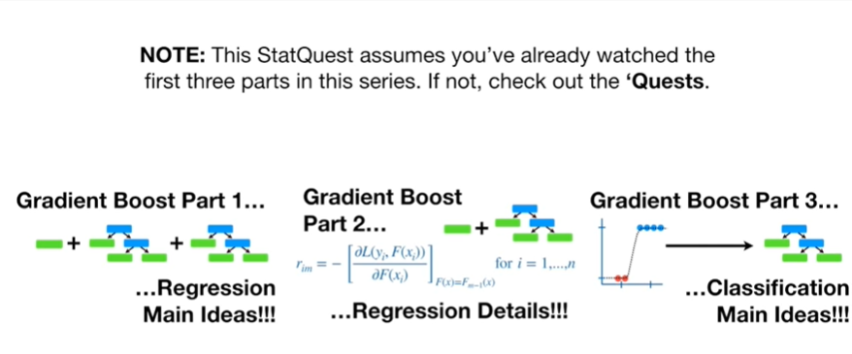

Note : this stat quest assumes you've already watched the first three parts in this series, if not check out the quests.

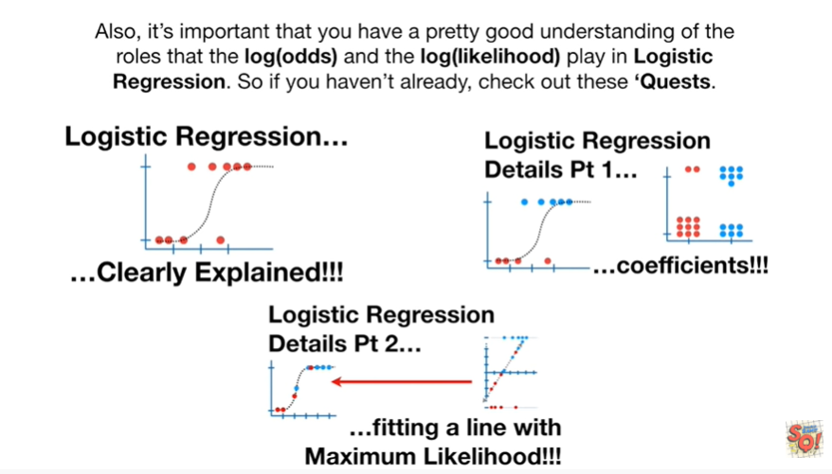

Also it's important that you have a pretty good understanding of the roles that the log odds and the log likelihood play in logistic regression, so if you haven't already, check out these quests.

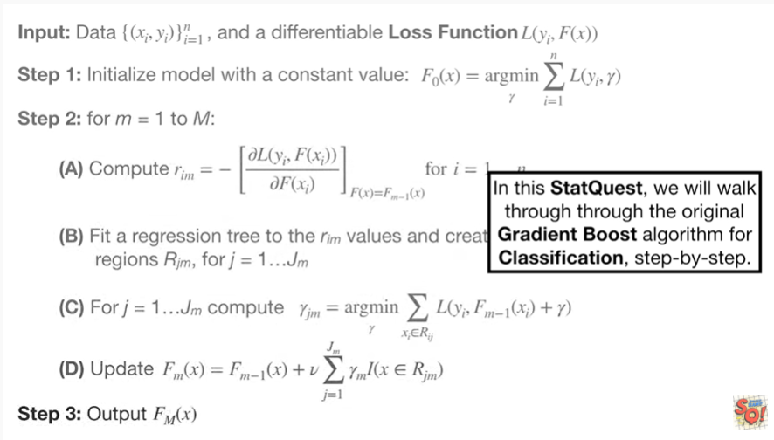

In this stat quest, we will walk through the original gradient boost algorithm for classification, step by step.

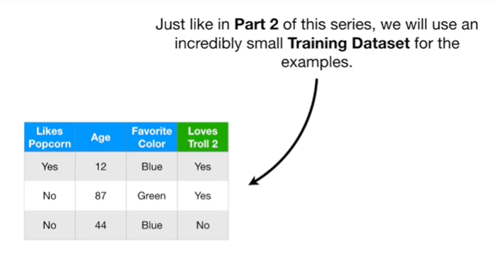

Just like in part two of this serie,s we will use an incredibly small training set for the examples.

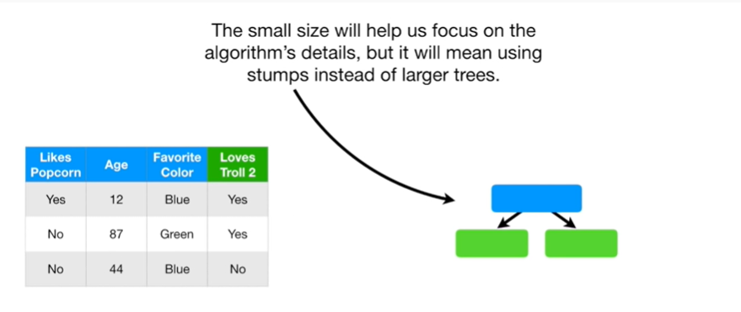

The small size will help us focus on the algorithms details but it will mean using stumps instead of trees.

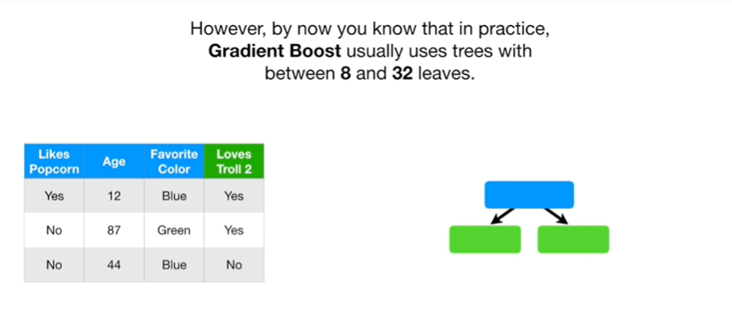

However by now you know that in practice gradient boost usually uses trees with between 8 and 32 leaves.

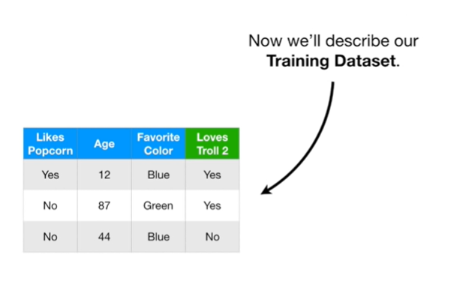

Now we'll describe our training data set.

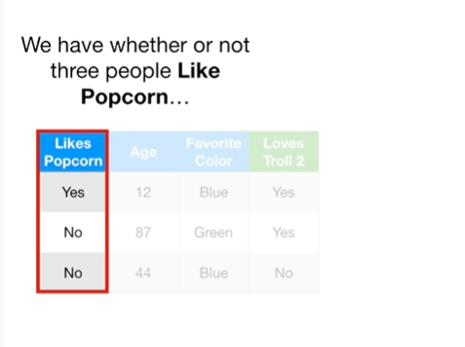

We have whether or not three people like popcorn

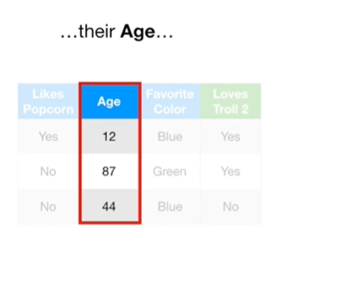

their age

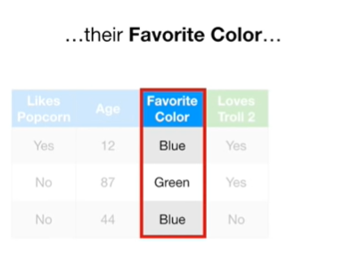

their favorite color



and whether or not they loved the movie troll 2.

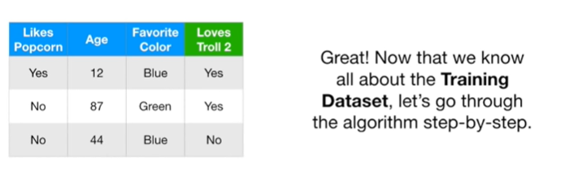

Great !

Now that we know all about the training data set let's go through the algorithm step by step.

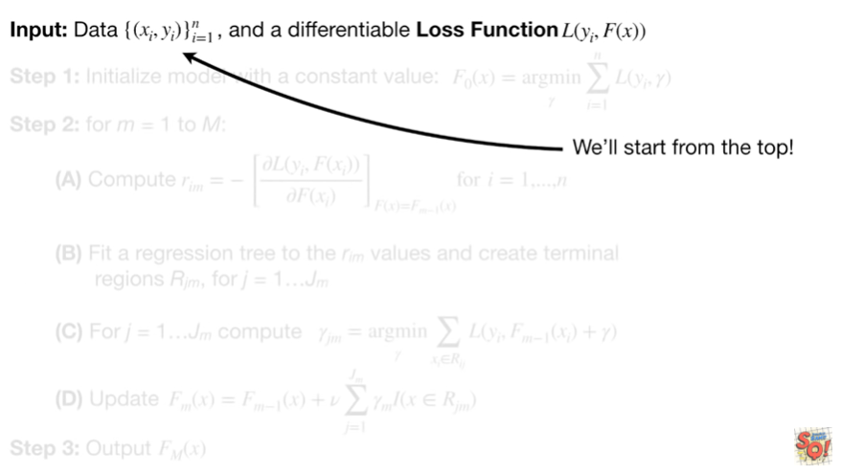

We'll start from the top.

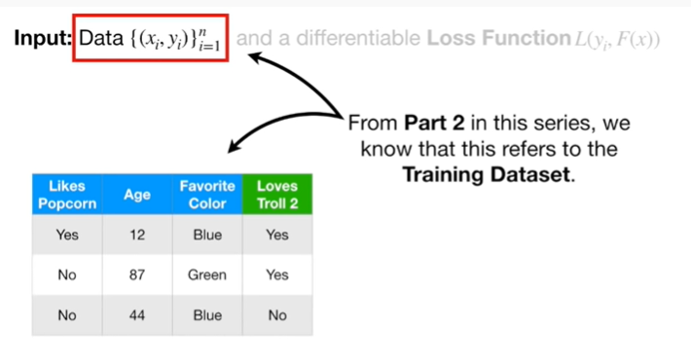

From part two in this series, we know that this refers to the training data set.

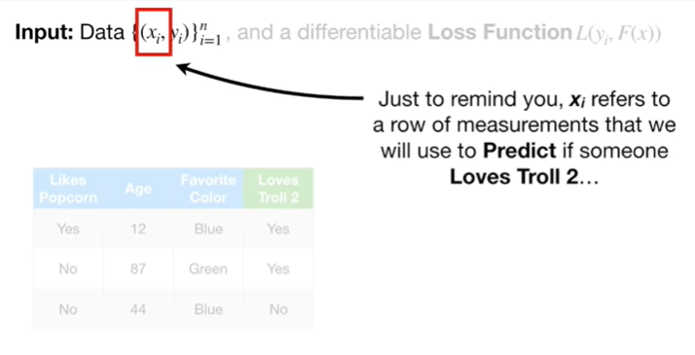

Just to remind you X sub i refers to a row of measurements that we will use to predict if someone loves troll 2

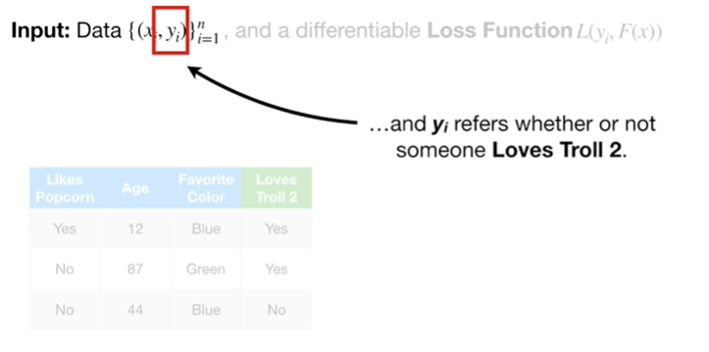

and y sub i refers to whether or not someone loves troll 2.

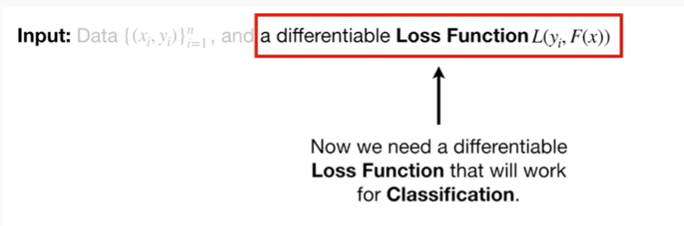

Now we need a differentiable loss function that will work for classification.

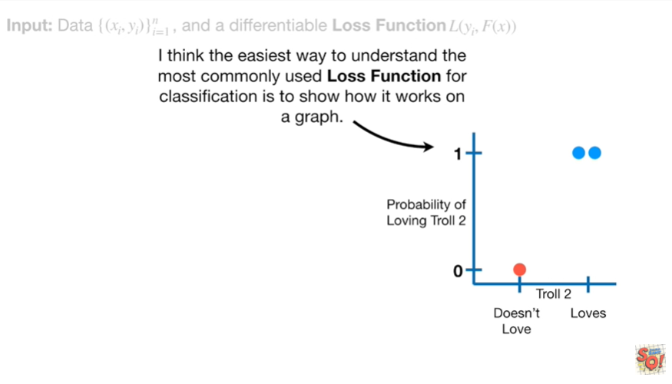

I think the easiest way to understand the most commonly used loss function for classification is to show how it works on a graph.

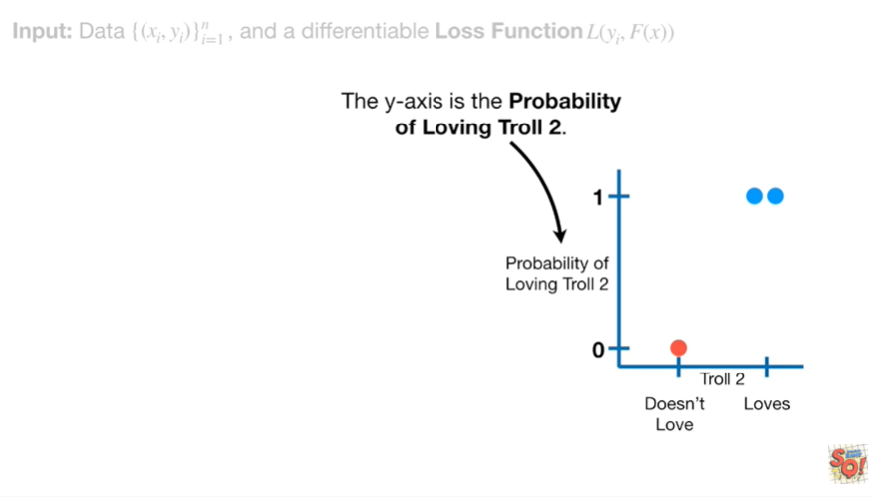

The y axis is the probability of loving troll 2.

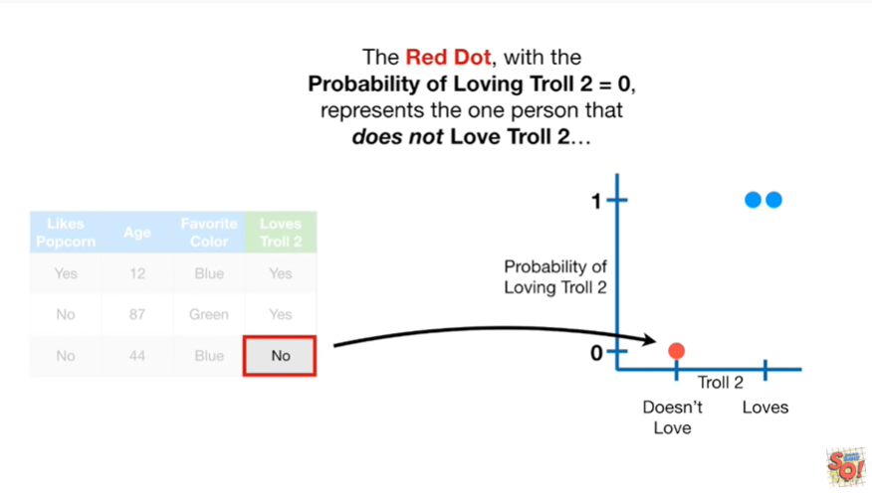

The red dot with the probability of loving troll 2 equal to zero, represents the one person that does not love troll 2.

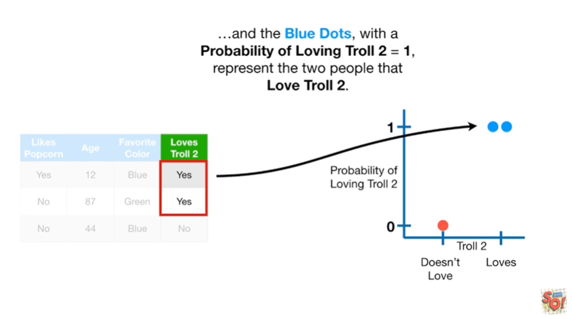

And the blue dots with the probability of loving troll 2 equal to 1, represent the two people that love troll 2.

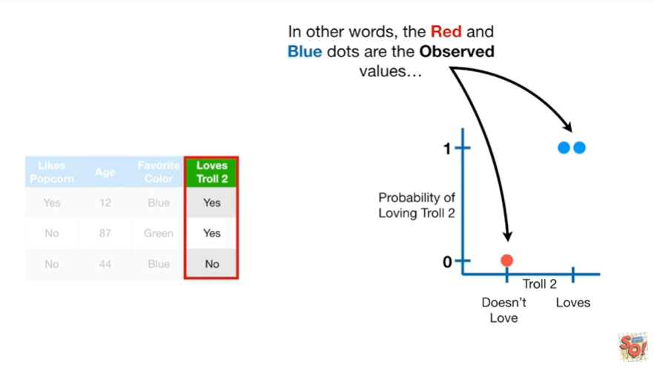

In other words, the red and blue dots are the observed values

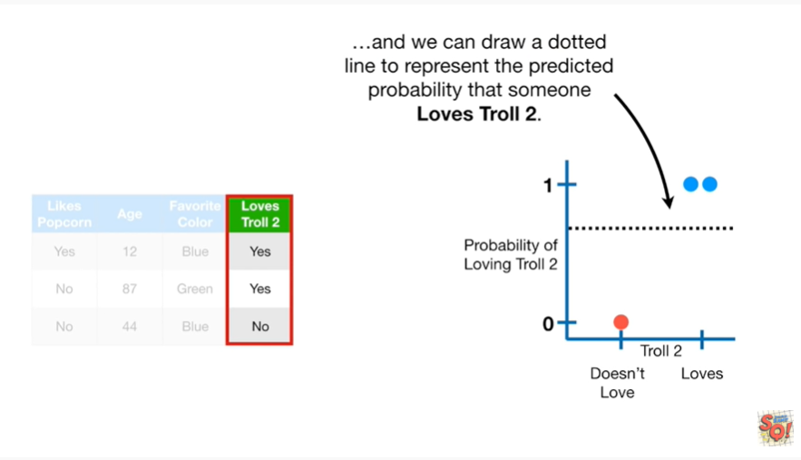

and we can draw a dotted line to represent the predicted probability that someone loves troll 2.

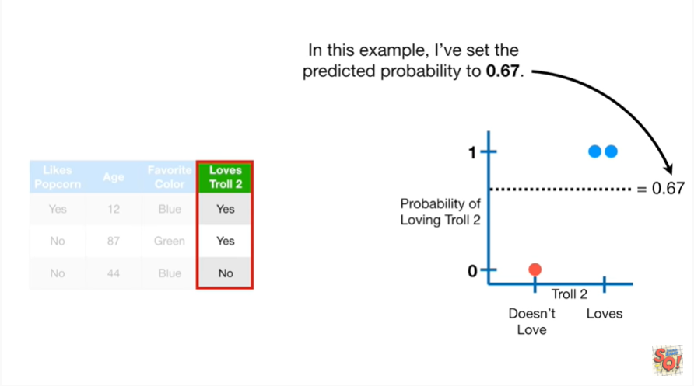

In this example I've set the predicted probability to 0.67.

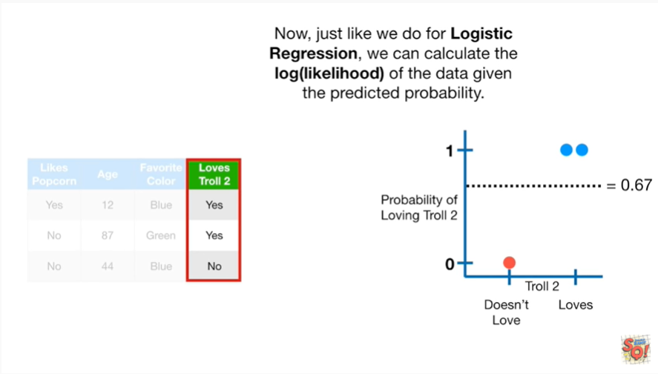

Now, just like we do for logistic regression, we can calculate the log likelihood of the data given the predicted probability.

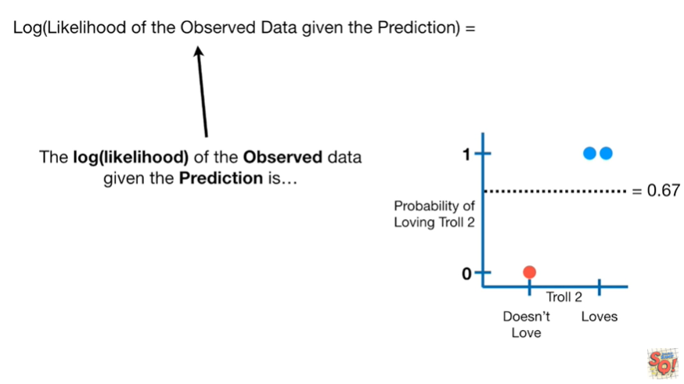

The log likelihood of the observed data given the prediction is this nasty-looking summation.

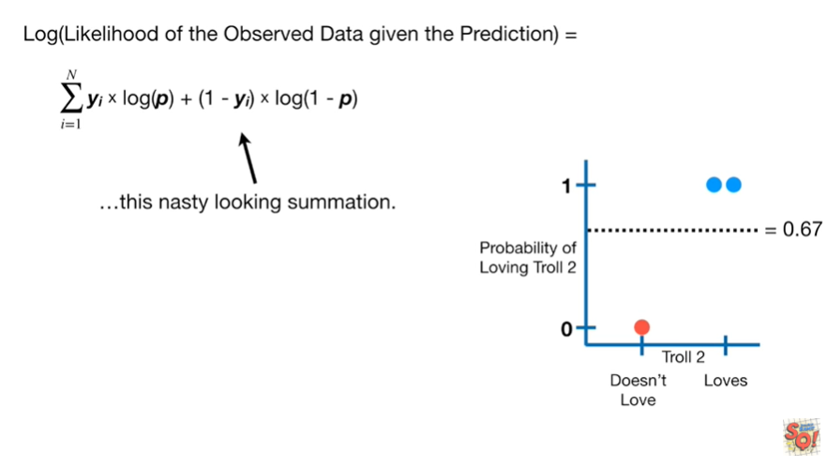

The p’s refer to the predicted probability which is 0.67 in this example

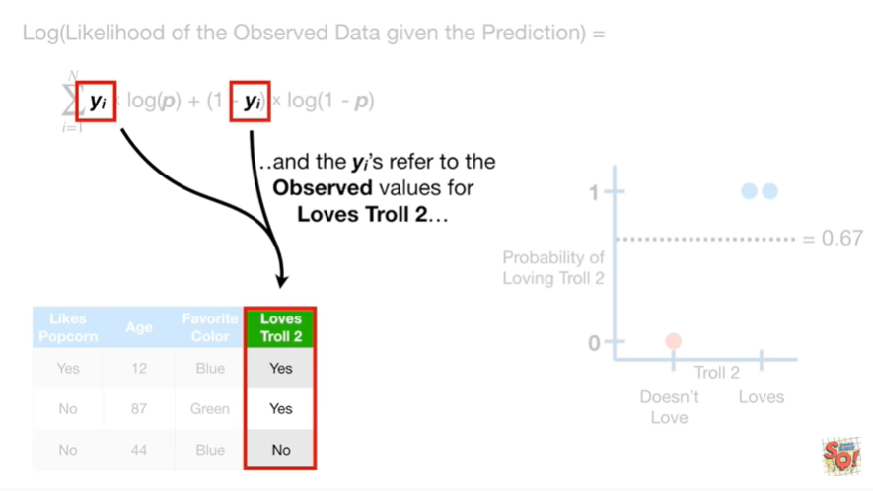

and the y sub i's refer to the observed values for loves troll 2.

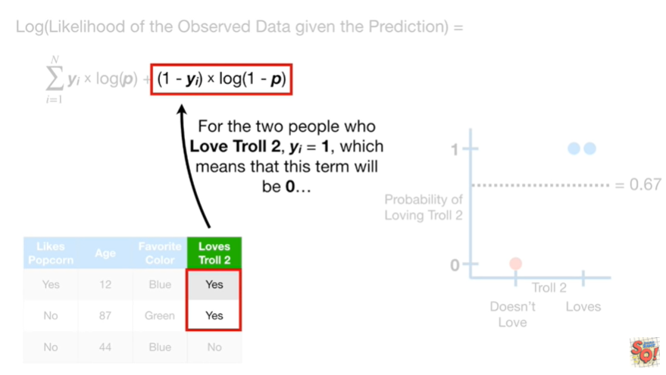

For the two people who love troll 2, y sub i equals 1, which means that this term will be 0

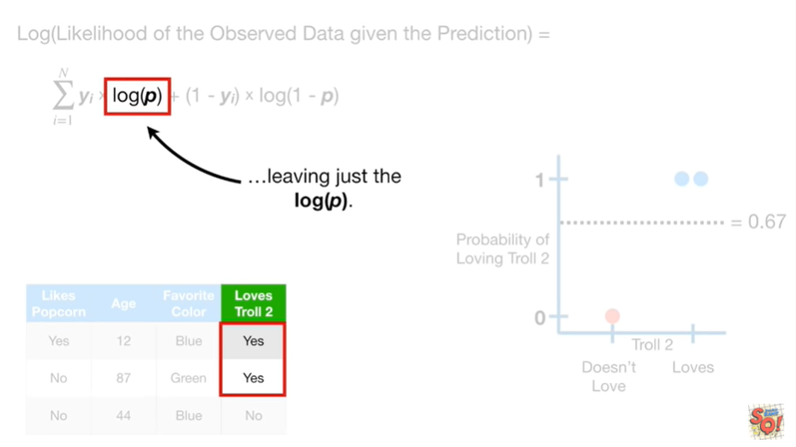

leaving just the log of p.

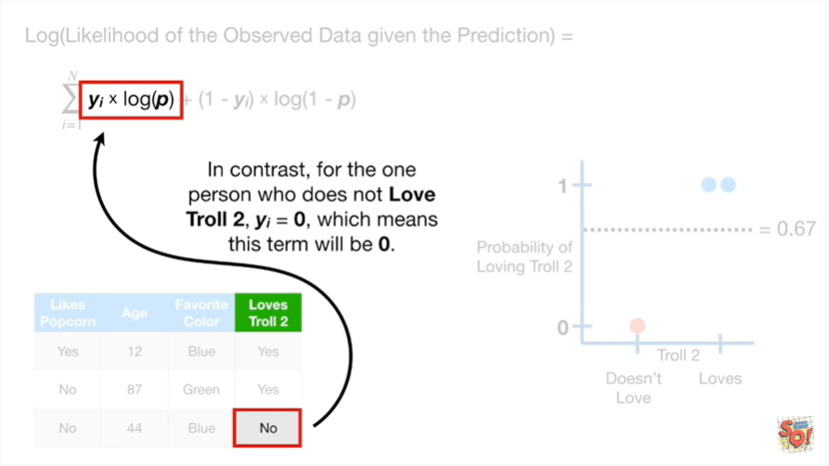

In contrast, for the one person who does not love troll 2, y sub i equals 0, which means that this term will be 0

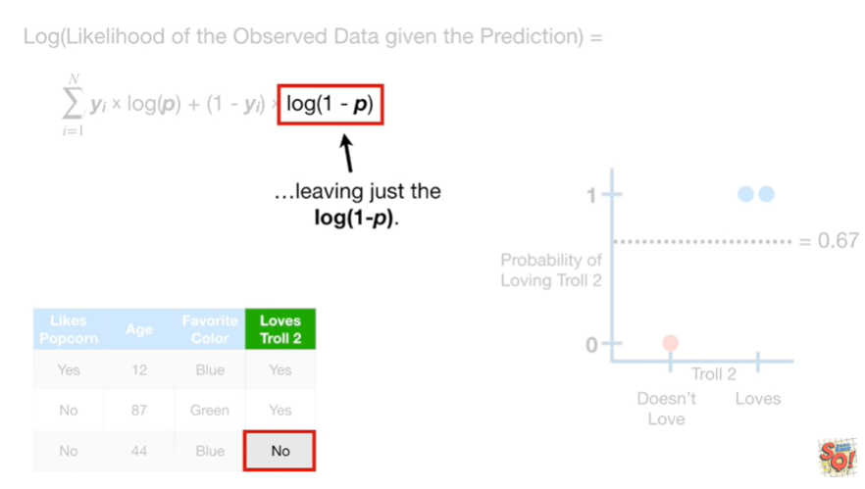

leaving just the log of (1 minus p).

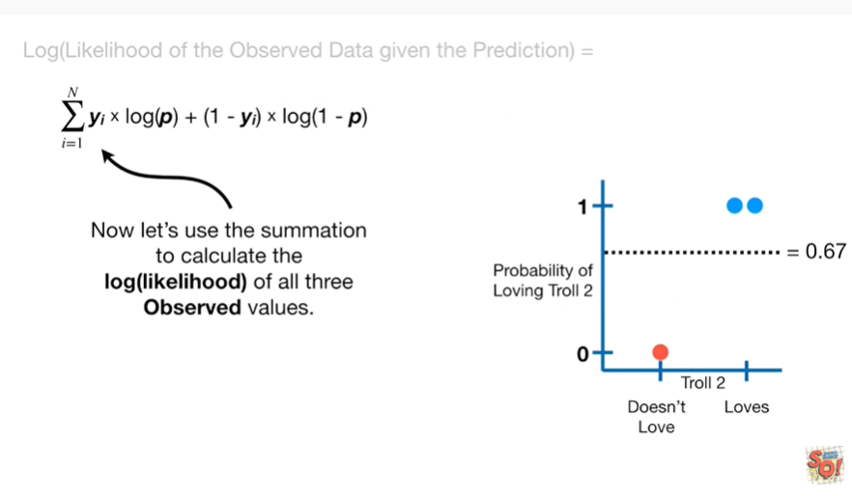

Now let's use the summation to calculate the log likelihood of all 3 observed values.

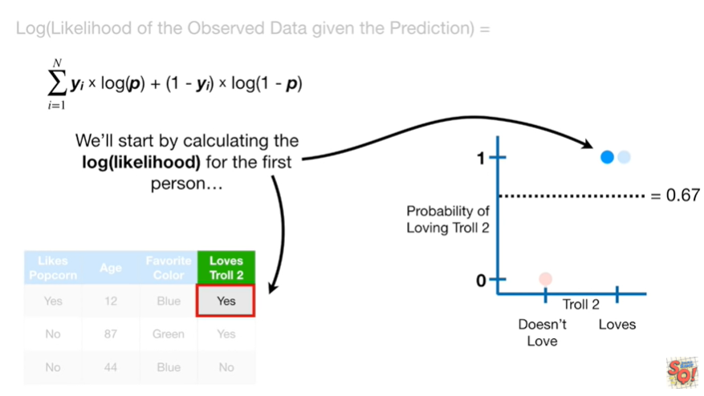

We'll start by calculating the log likelihood for the first person.

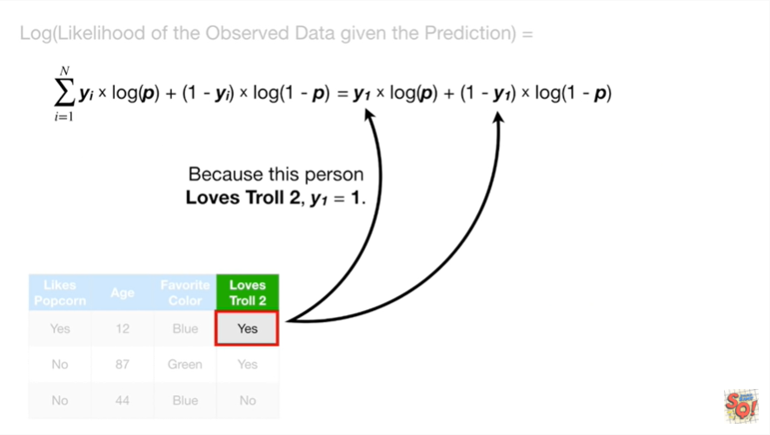

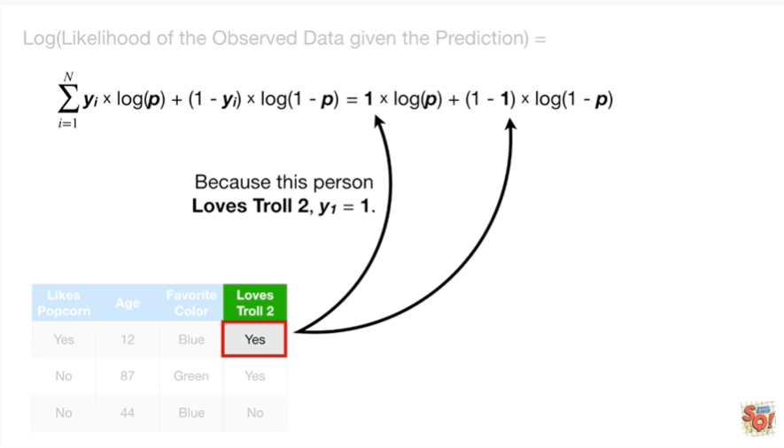

Because this person loves troll 2, y sub 1 equals 1

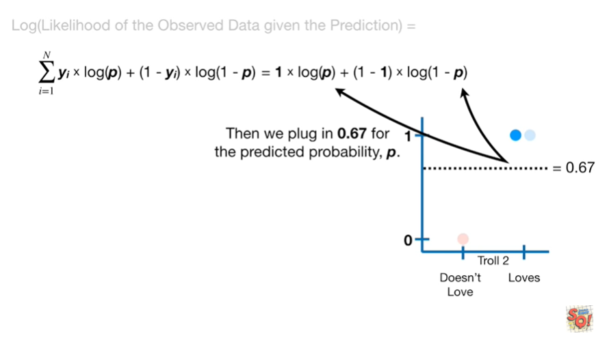

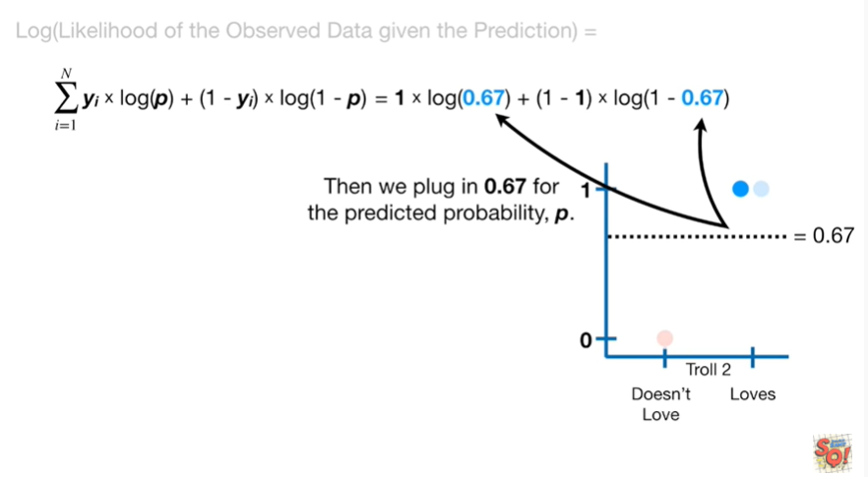

then we plug in 0.67 for the predicted probability p.

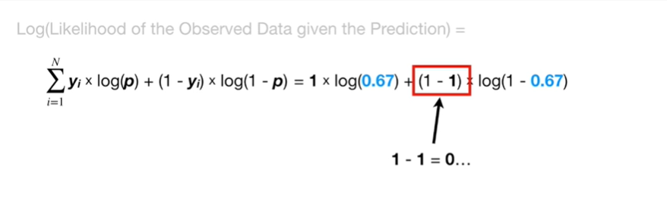

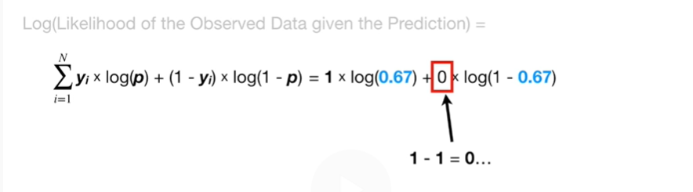

1 minus one equals zero

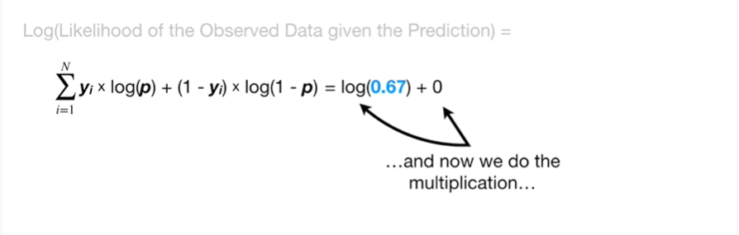

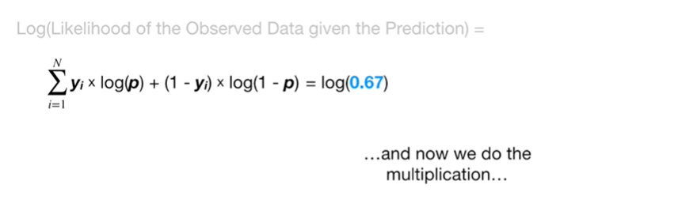

and now we do the multiplication

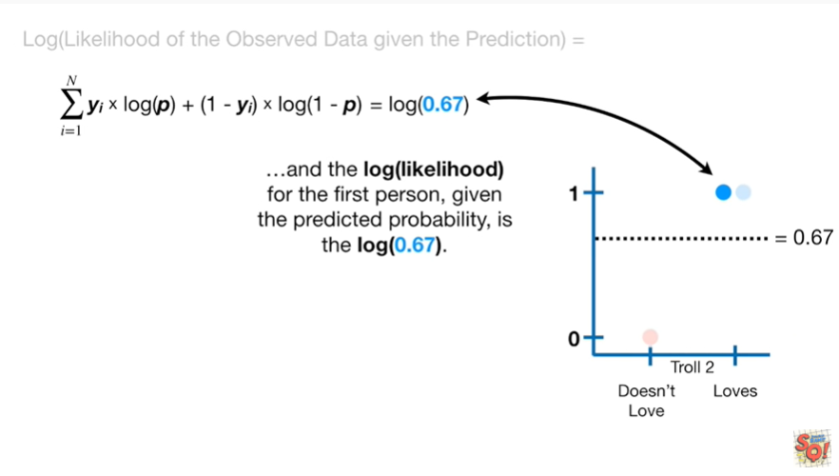

and the log-likelihood for the first person given the predicted probability is the log of 0.67.

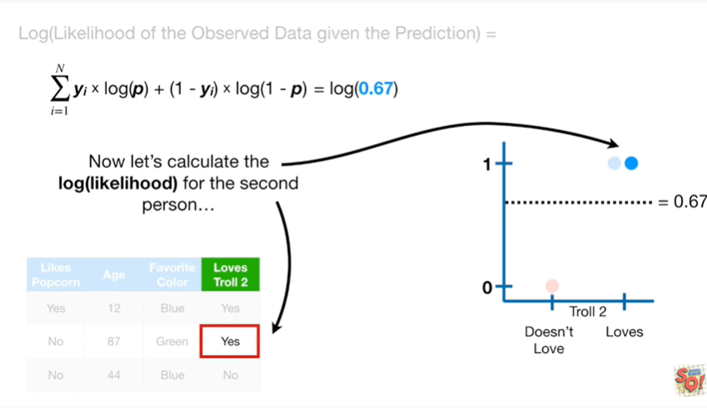

Now let's calculate the log likelihood for the second person.

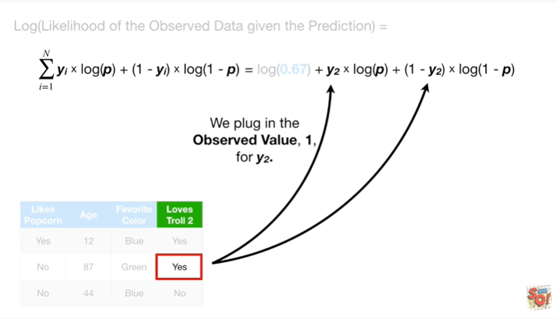

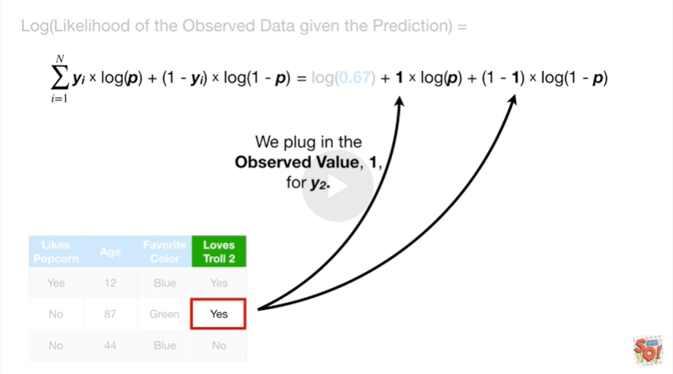

We plug in the observed value one for y sub two

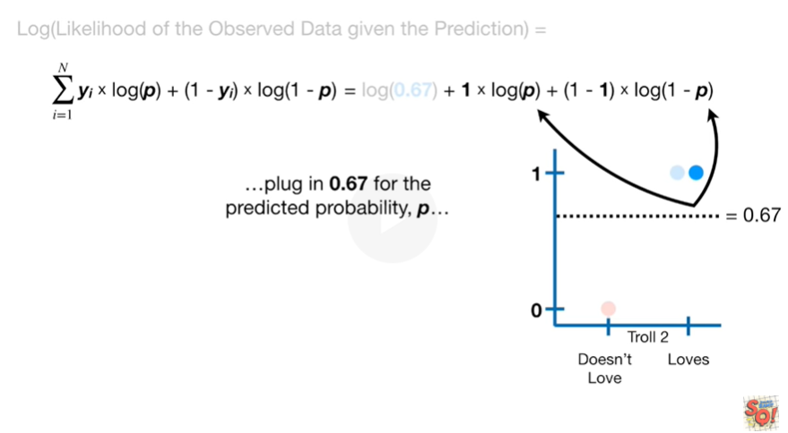

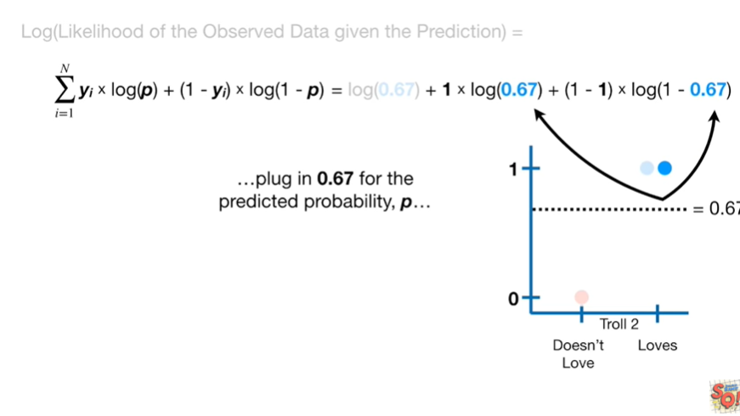

and plug in 0.67 for the predicted probability p.

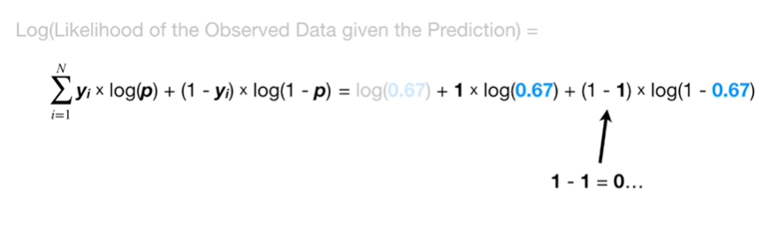

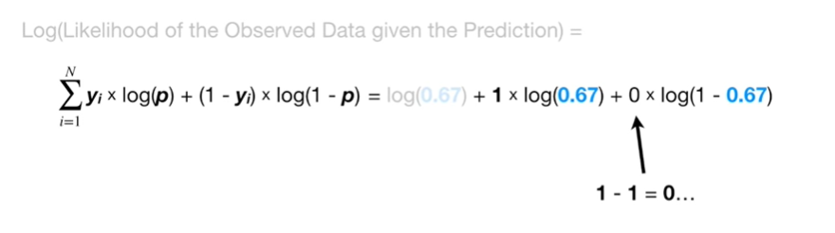

1 minus one equals zero

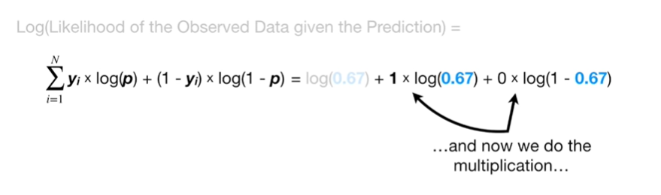

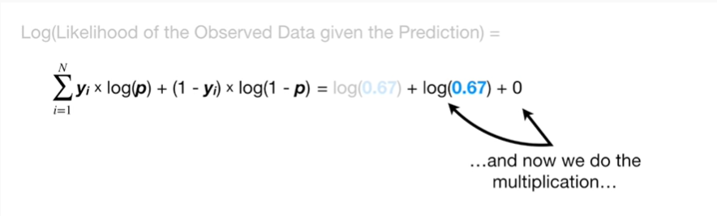

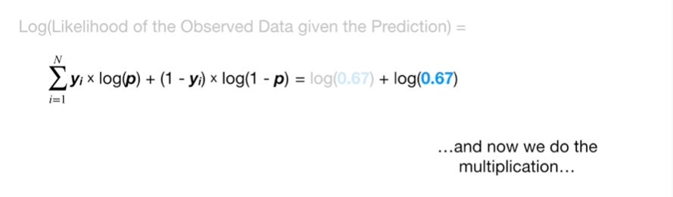

and now we do the multiplication

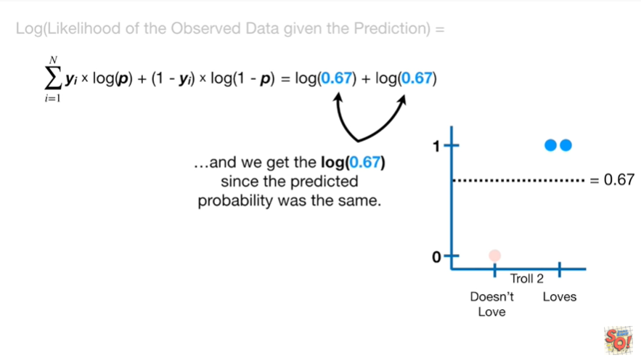

and we get the log of 0.67 since the predicted probability was the same.

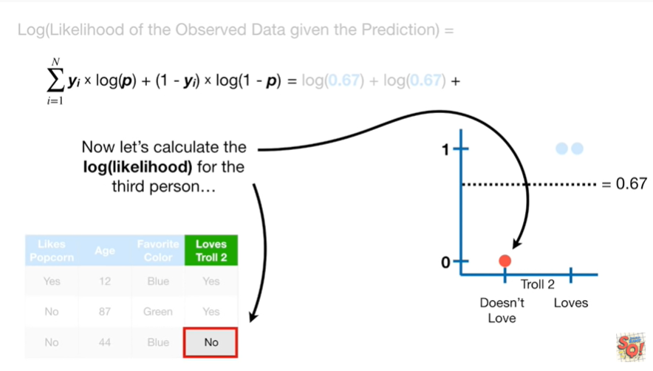

Now let's calculate the log likelihood for the third person.

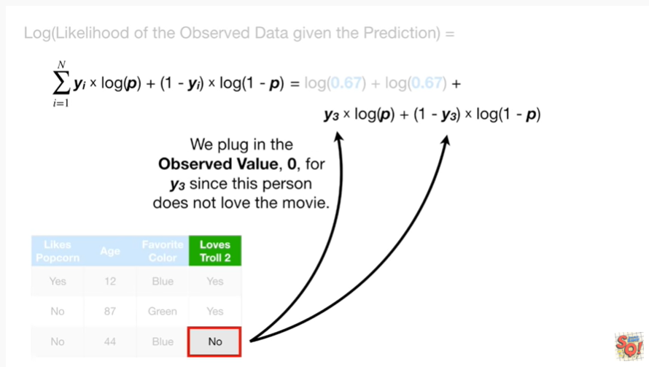

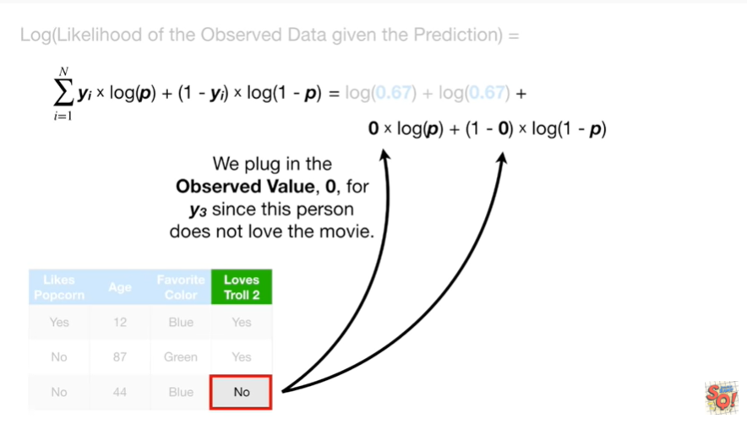

We plug in the observed value 0 for y sub 3 since this person does not love the movie

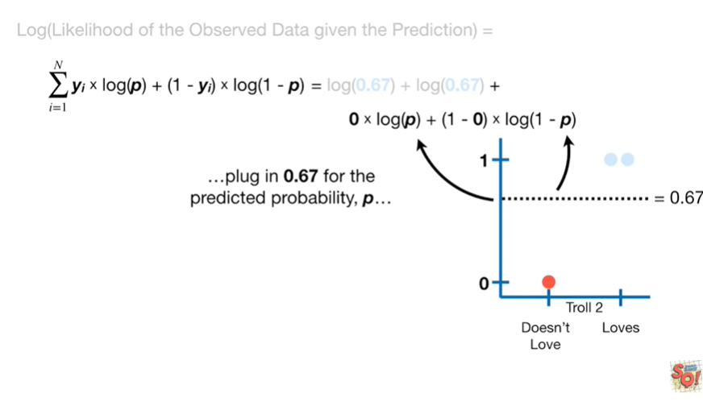

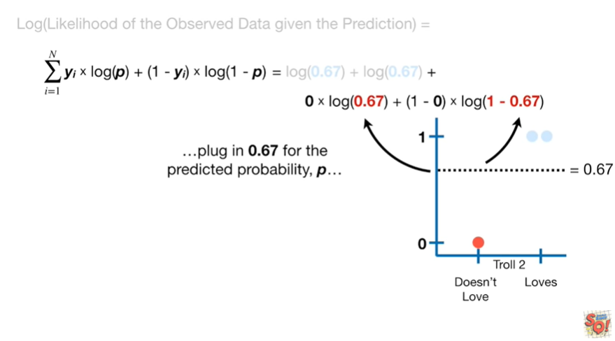

plug in 0.67 for the predicted probability p

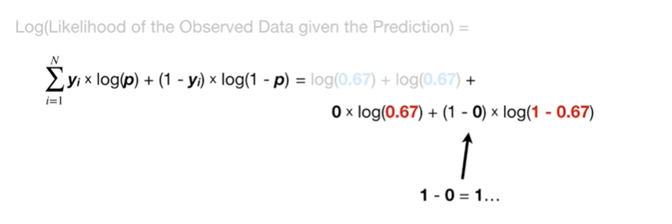

1 minus 0 equals 1

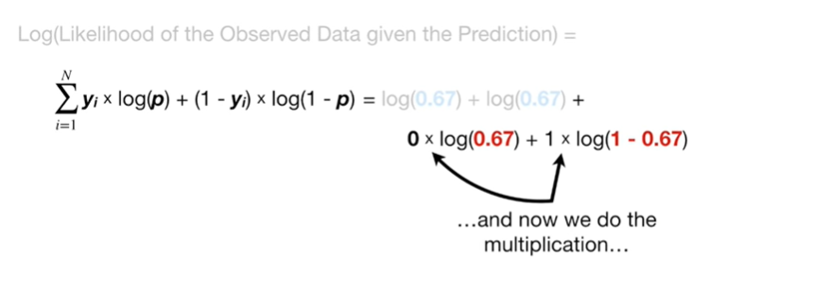

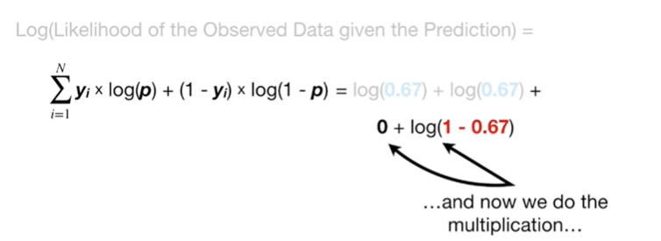

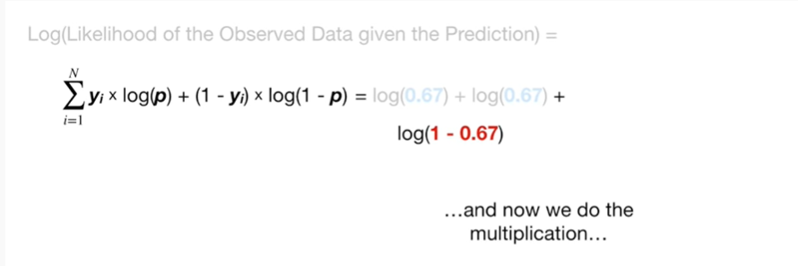

and now we do the multiplication

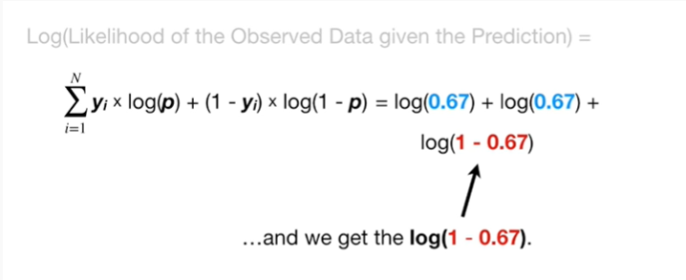

and we get the log of 1 minus 0.67.

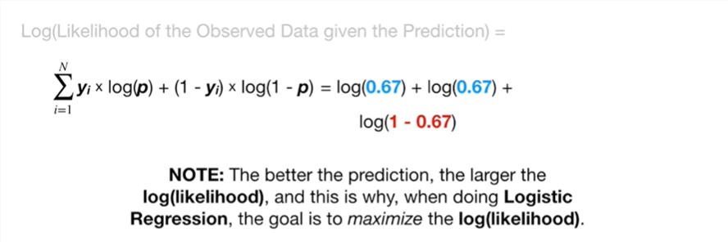

Note : the better the prediction, the larger the log-likelihood, and this is why ,when doing logistic regression, the goal is to maximize the log likelihood.

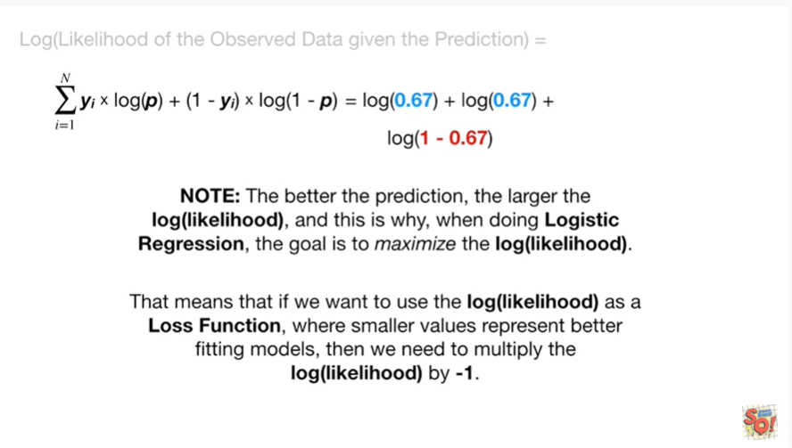

That means that if we want to use the log likelihood as a loss function, where smaller values represent better fitting models, then we need to multiply the log likelihood by negative one.

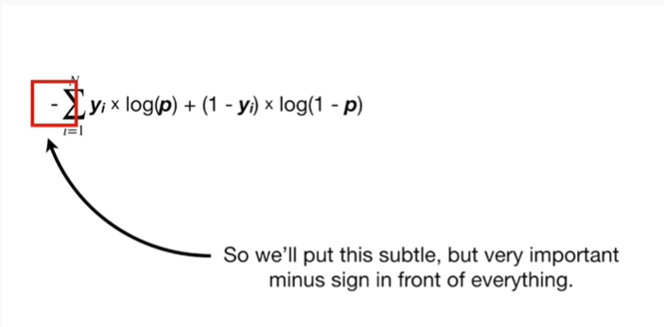

So we'll put this subtle but very important minus sign in front of everything.1

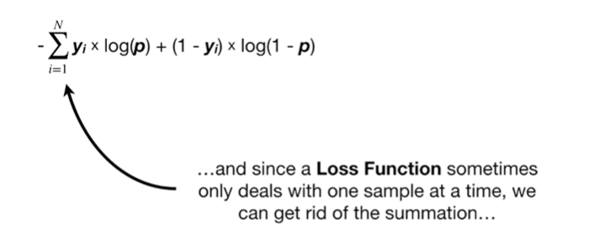

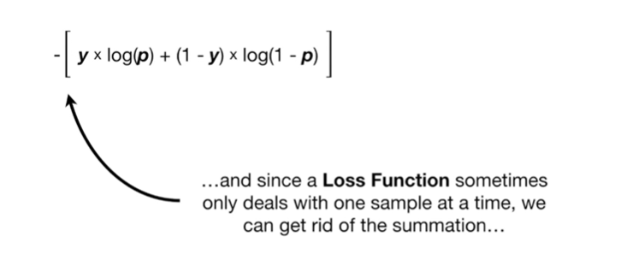

And since a loss function sometimes only deals with one sample at a time, we can get rid of the summation

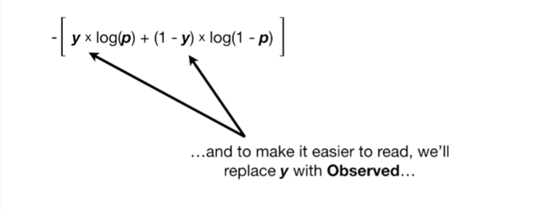

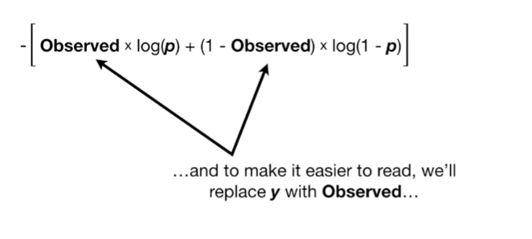

and to make it easier to read, we'll replace Y with observed

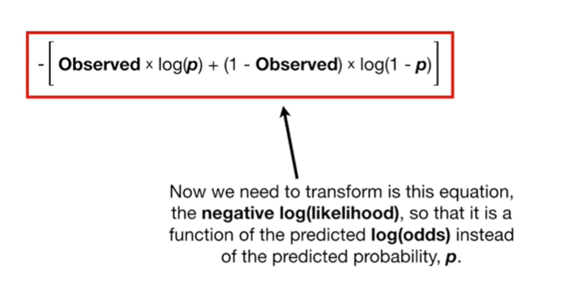

Now we need to transform this equation, the negative log likelihood, so that it is a function of the predicted log odds instead of the predicted probability, p.

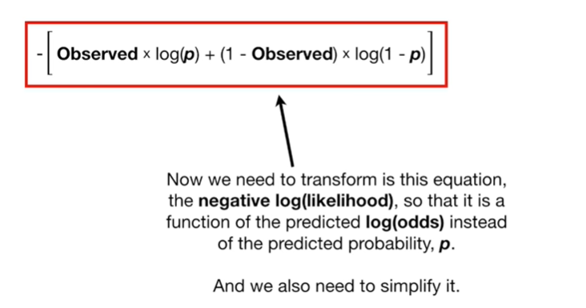

And we need to simplify it.

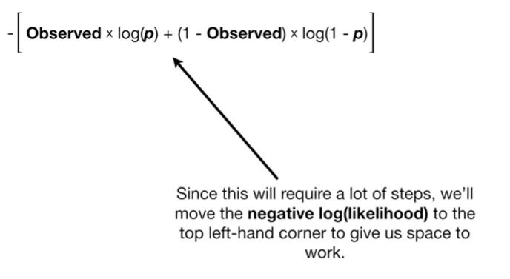

Since this will require a lot of steps we'll move the negative log likelihood to the top left-hand corner to give a space to work.

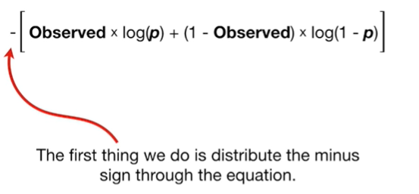

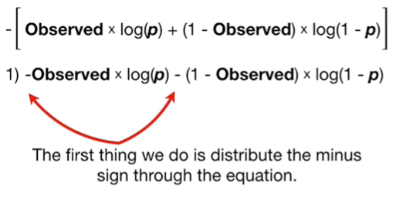

The first thing we do is distribute the minus sign through the equation

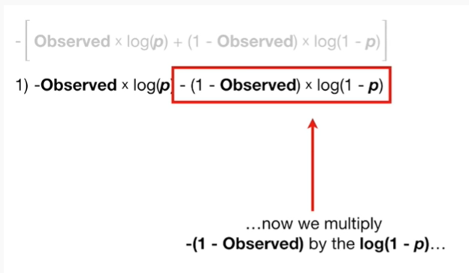

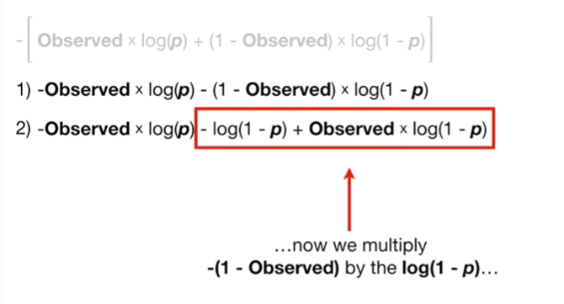

now we multiply the negative 1 minus observed by the log of 1 minus P.

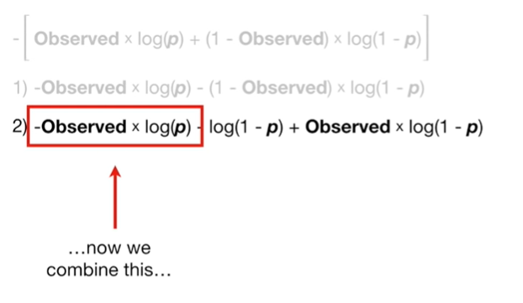

now we combine this

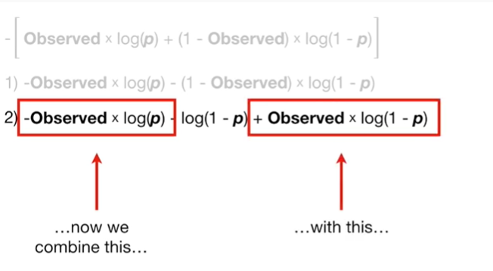

with this

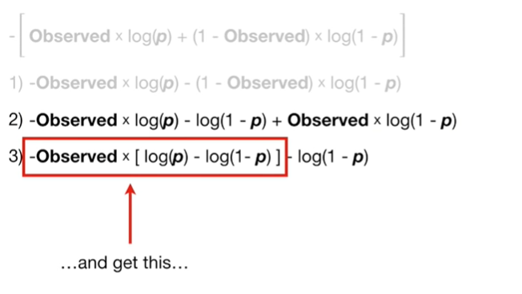

and get this

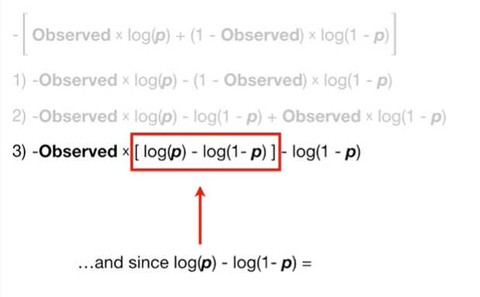

and since the log of P minus the log of 1 minus P

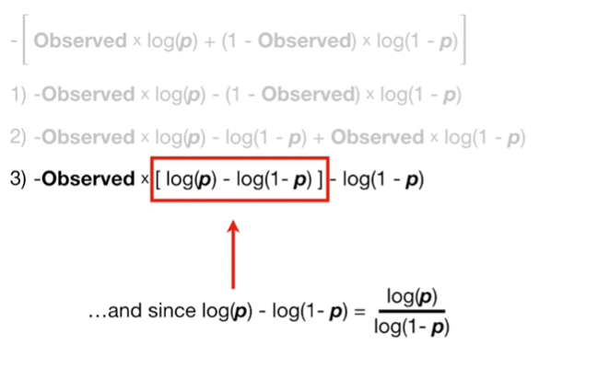

equals the log of P divided by the log of 1 minus P

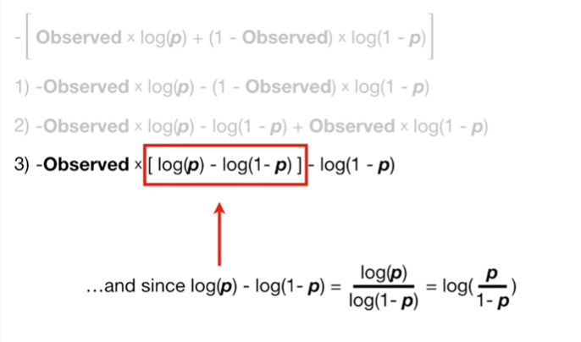

and that equals the log of P divided by 1 minus P

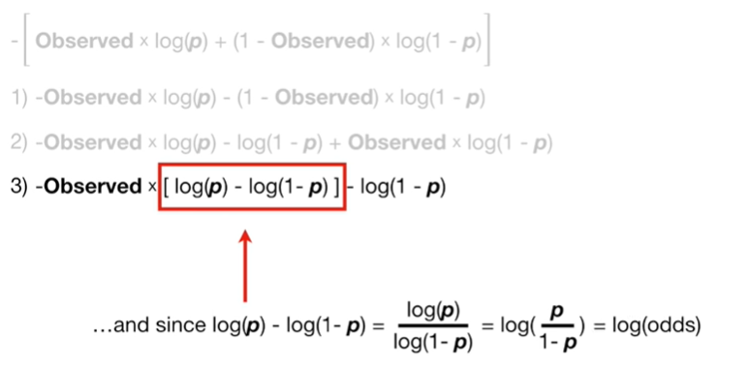

and that equals the log of the odds

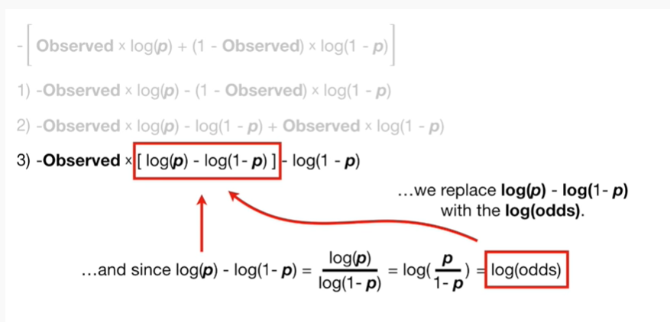

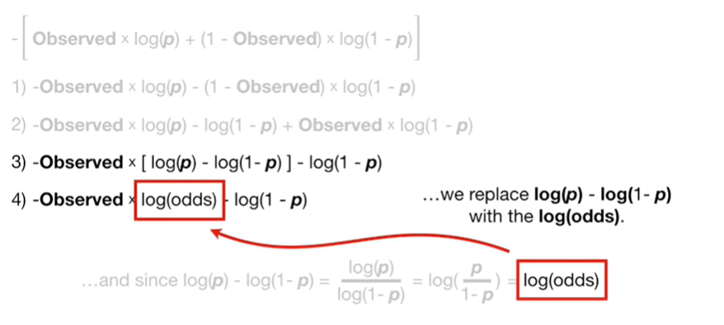

so we replace the log of P minus the log of 1 minus P with the log of the odds.

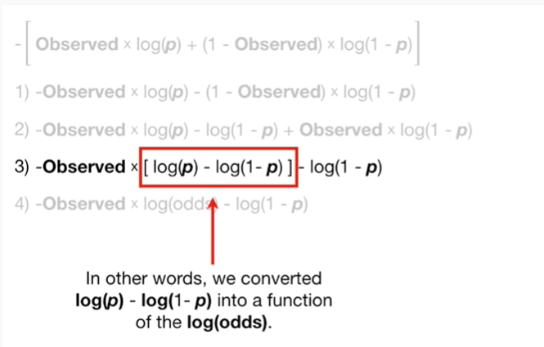

In other words we converted the log of p minus the log of one minus

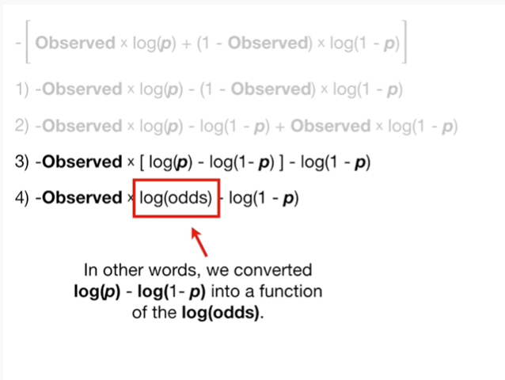

into a function of the log of the odds.

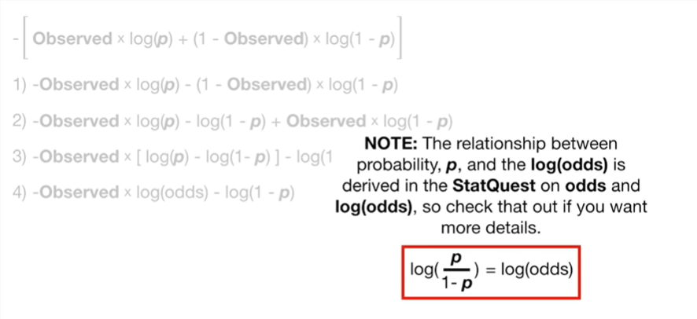

Note : the relationship between probability P and the log of the odds is derived in the stack quest on odds and the log of the odds.

So check that out if you want more details.

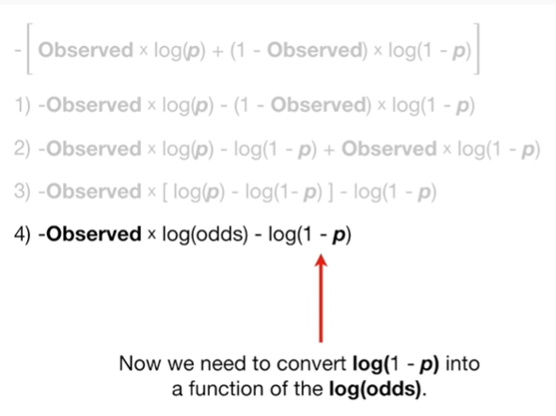

Now we need to convert the log of 1 minus P into a function of the log of the odds.

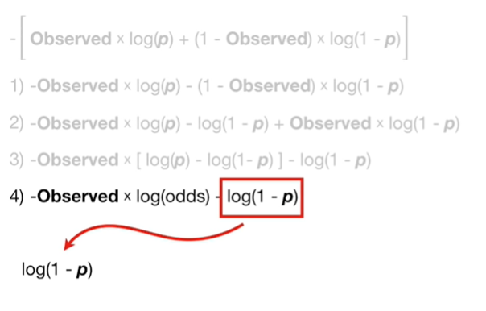

The log of 1 minus P equals the log of 1 minus e to the log odds divided by 1 plus e to the log odds.

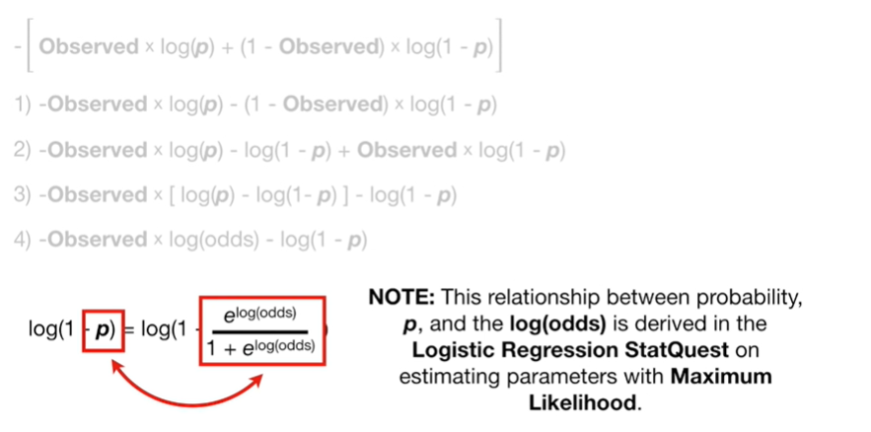

Note : this relationship between probability P and the log of the odds is derived in the logistic regression stack quest on estimating parameters with maximum likelihood.

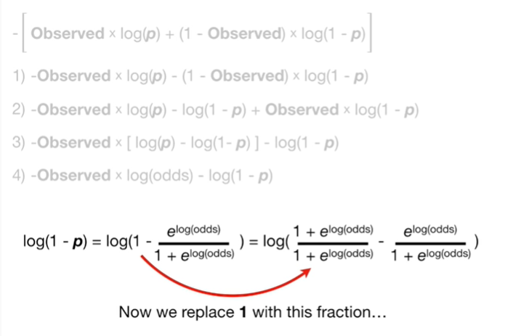

Now we replace 1 with this fraction

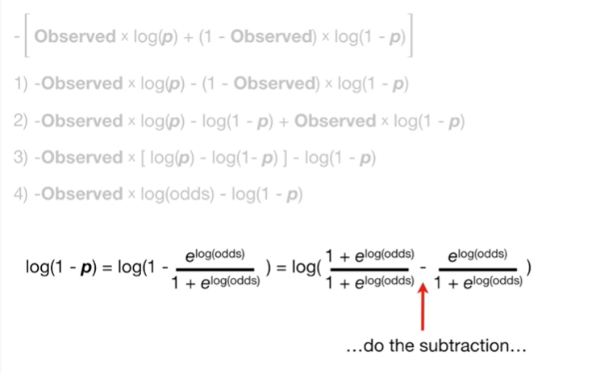

do the subtraction

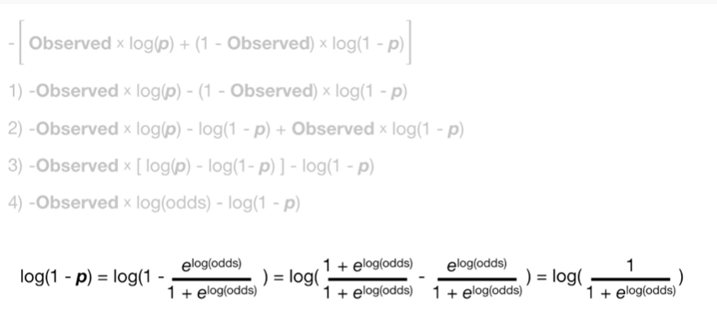

and we get the log of 1 divided by 1 plus e to the log odds

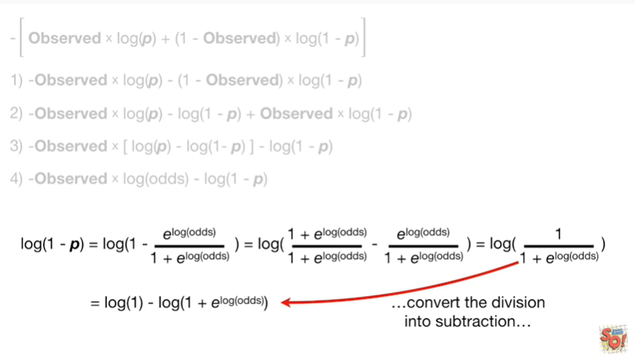

now convert the division into subtraction

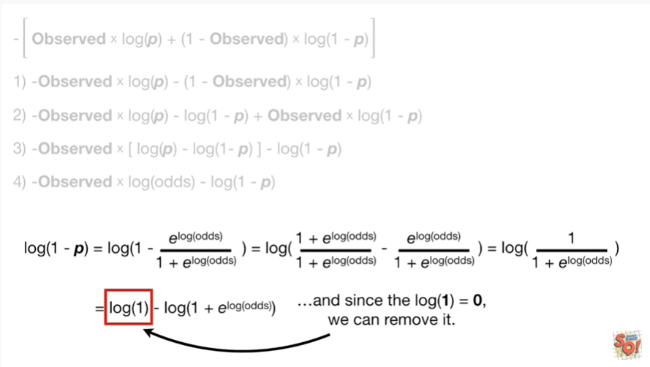

and since the log of 1 equals 0 we can remove it

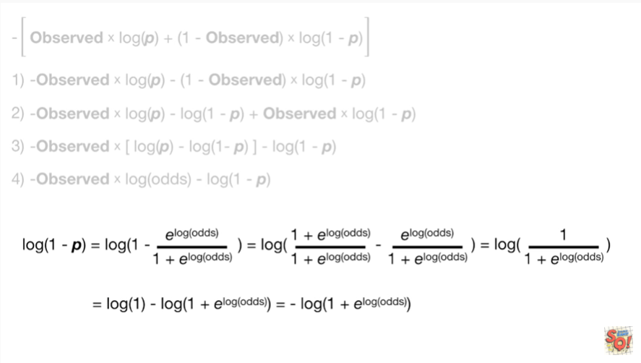

and that leaves us with the negative log of 1 plus e to the log odds.

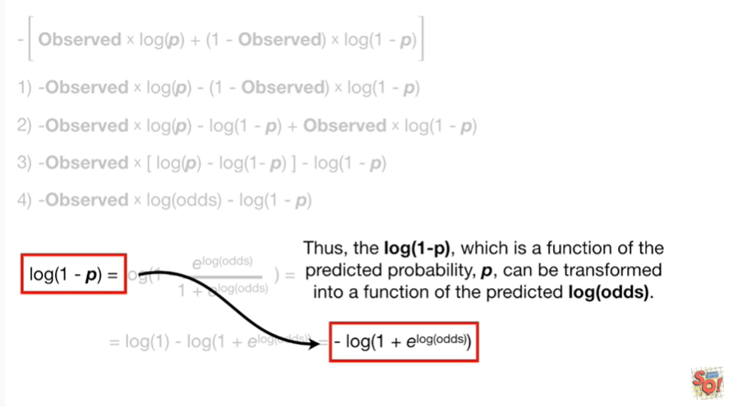

Thus the log of 1 minus P, which is a function of the predicted probability, P, can be transformed into a function of the predicted log odds.

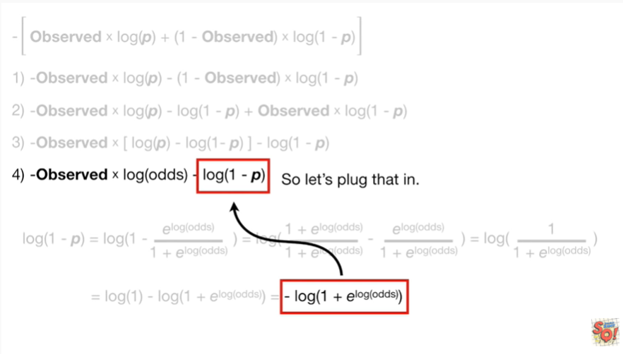

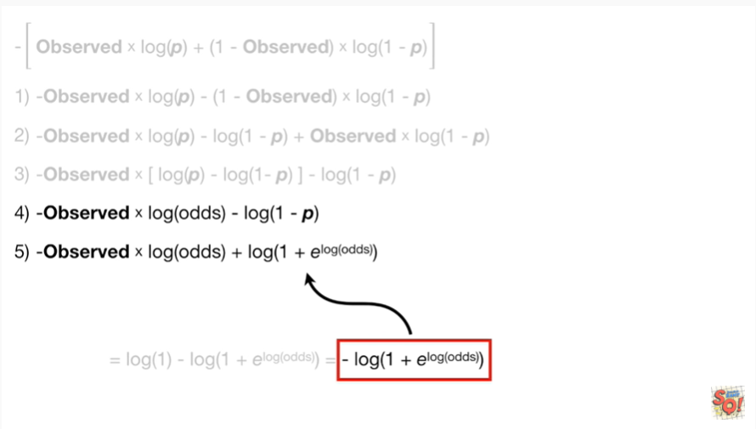

So let's plug that in.

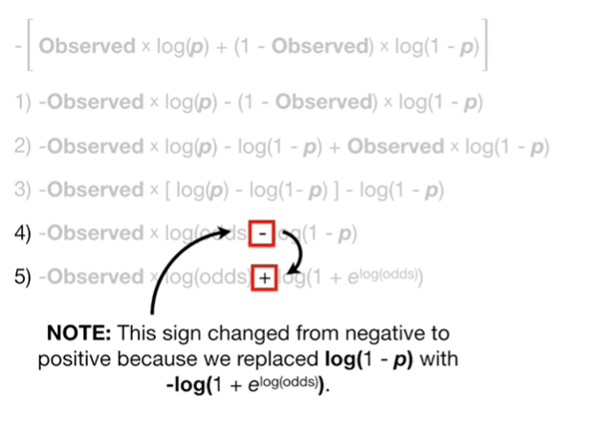

Note : this sign changed from negative to positive because we replace the log of 1 minus P with a negative log of 1 plus e to the log odds.

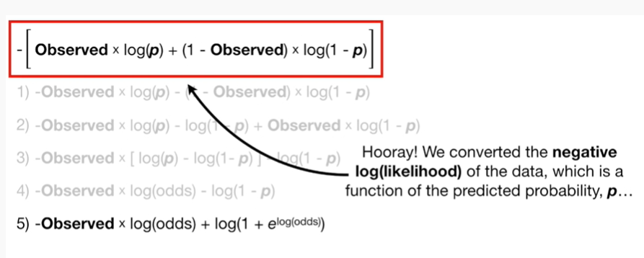

Hooray !

We converted the negative log likelihood of the data, which is a function of the predicted probability, P,

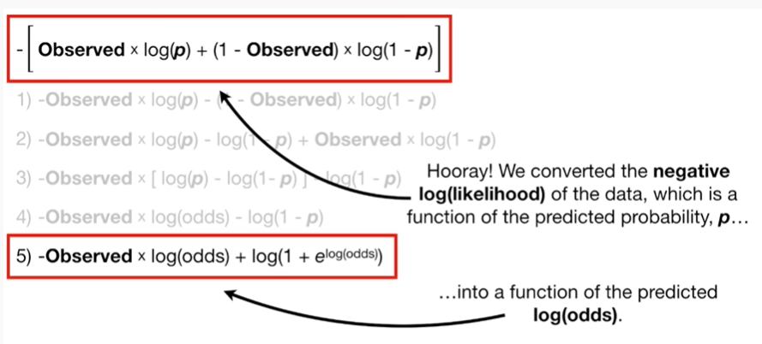

into a function of the predicted log odds.

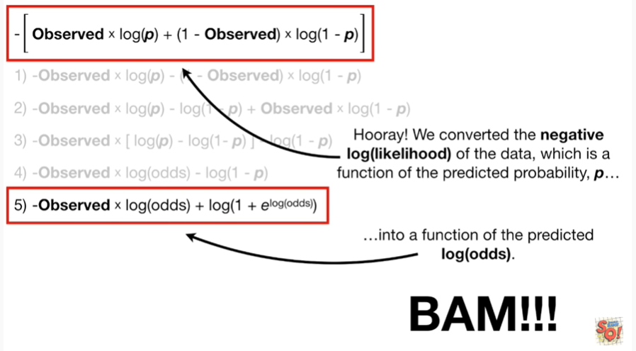

BAM !!!!

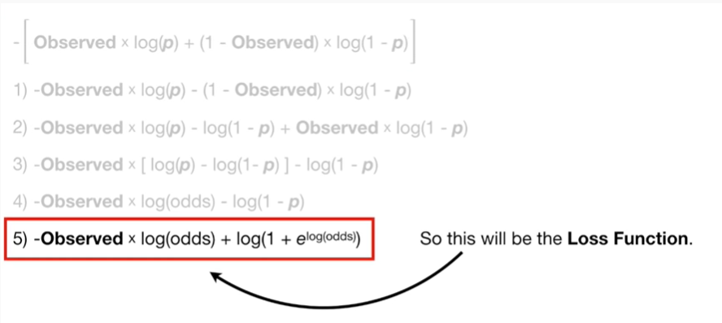

So this will be the loss function.

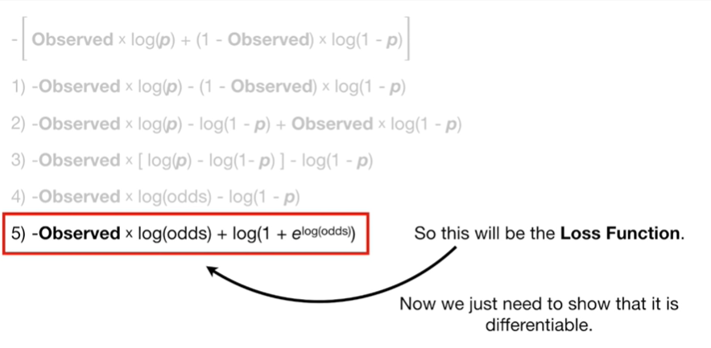

Now we just need to show that it is differentiable.

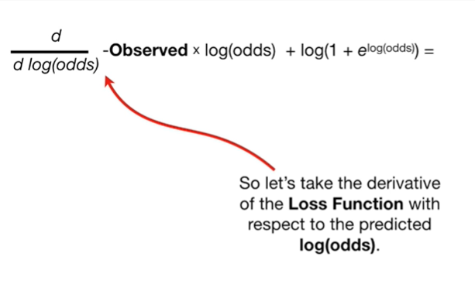

So let's take the derivative of the loss function with respect to the predicted log odds.

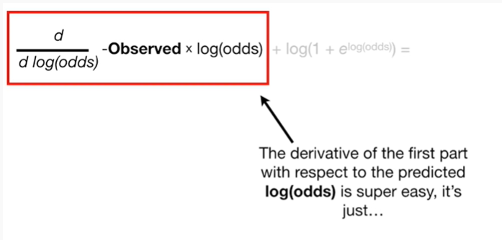

The derivative of the first part with respect to the predicted log odds is super easy

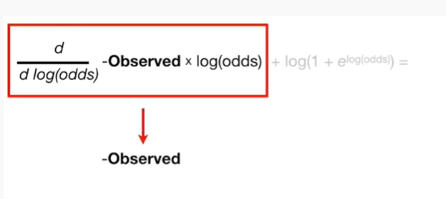

it's just the negative observed value.

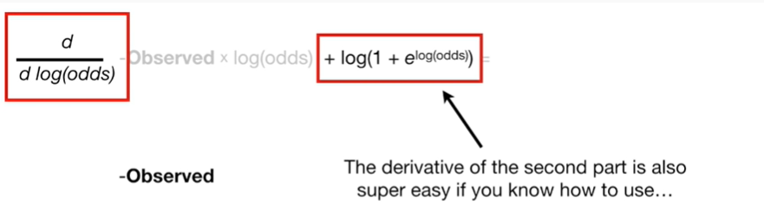

The derivative of the second part is also super easy if you know how to use



the chain rule

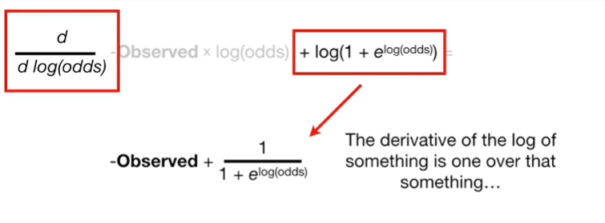

the derivative of the log of something is 1 over that something

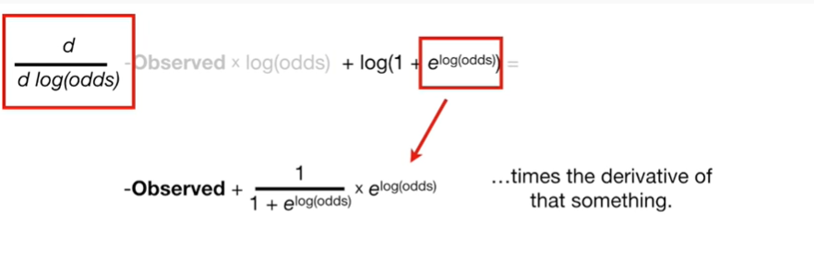

times the derivative of that something

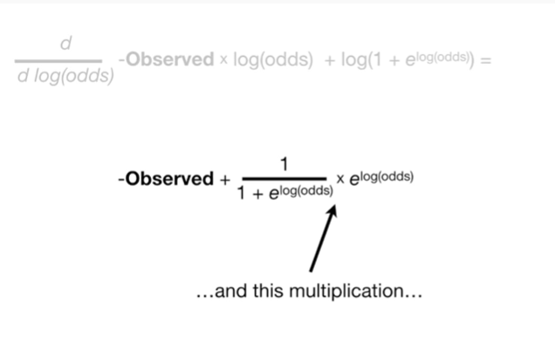

and this multiplication

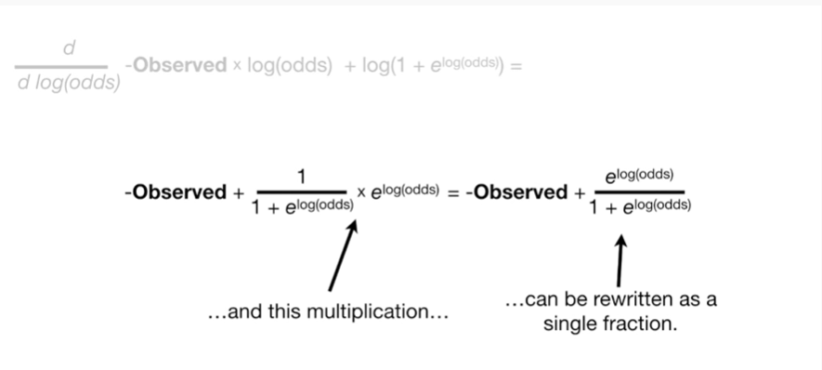

can be re-written as a single fraction.

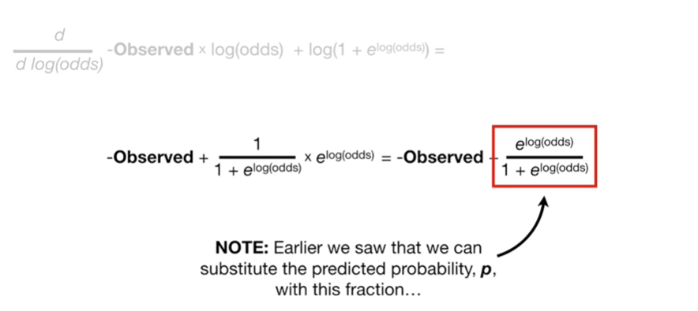

Note : earlier we saw that we can substitute the predicted probability P with this fraction

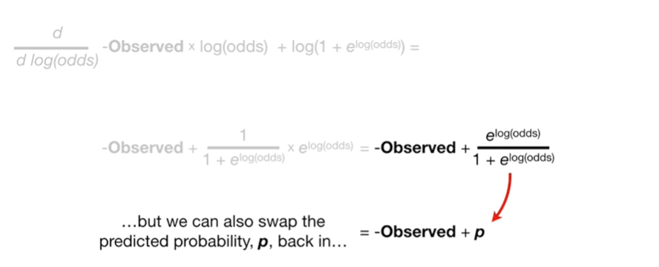

but we can also swap the predicted probability P back in

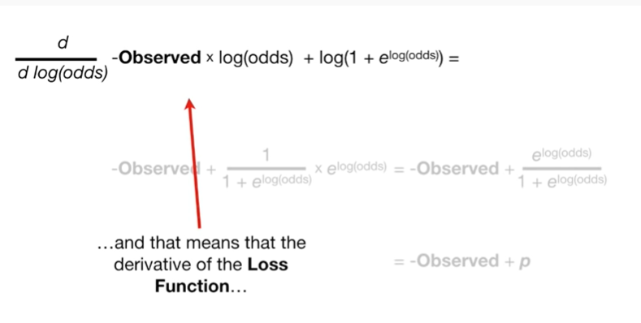

and that means that the derivative of the loss function

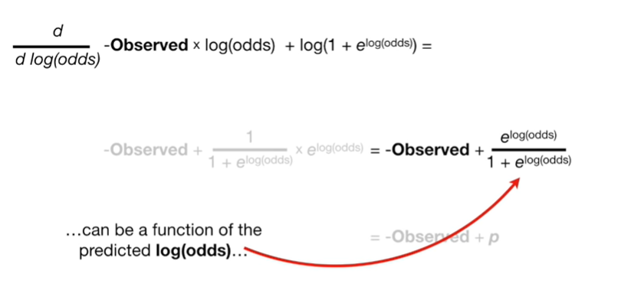

can be a function of the predicted log odds

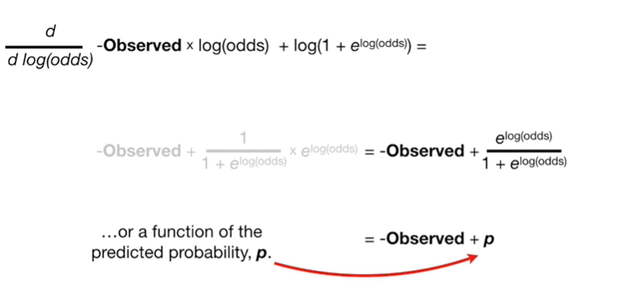

or a function of the predicted probability P.

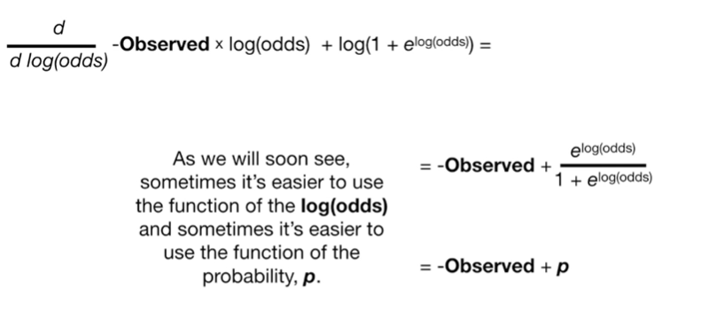

As we will soon see, sometimes it's easier to use the function of the log odds and sometimes it's easier to use the function of the predicted probability, P.

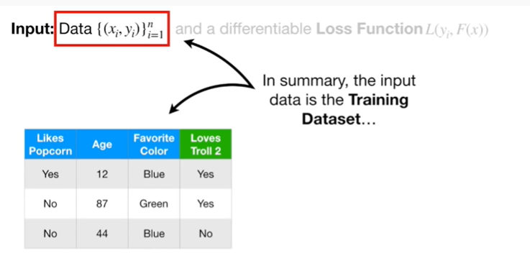

In summary, the input data is the training data set

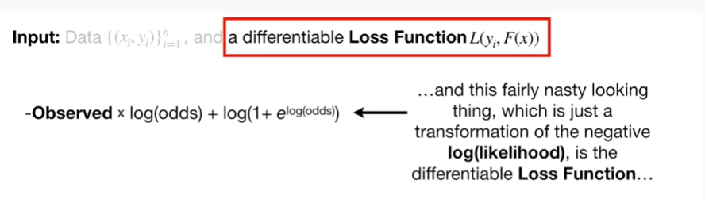

and this fairly nasty looking thing which is just a transformation of the negative log likelihood, is the differentiable loss function

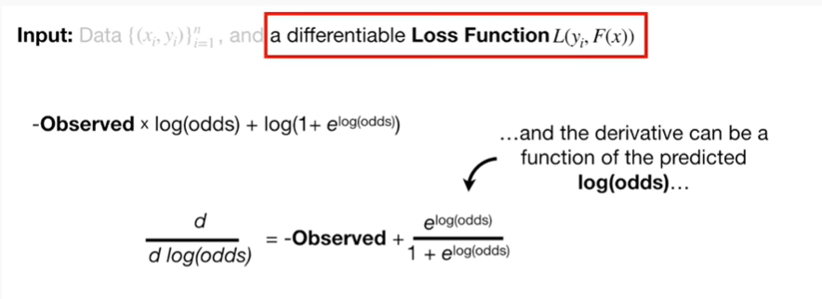

and the derivative can be a function of the predicted log odds

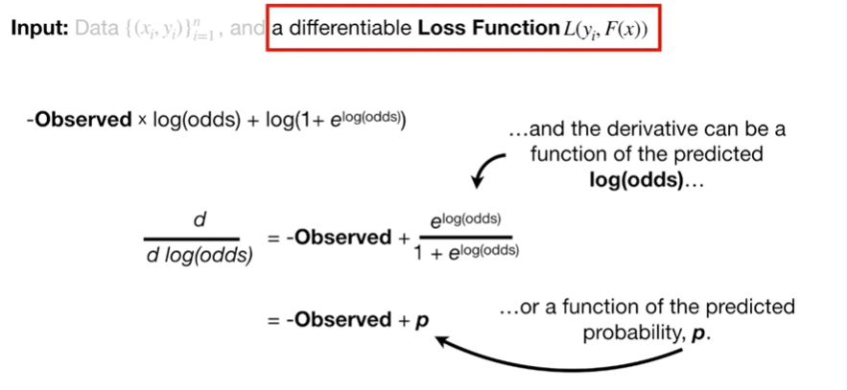

or a function of the predicted probability, P.

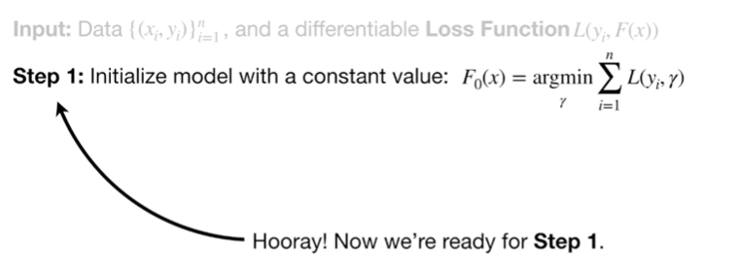

Hooray !

Now we're ready for step 1.

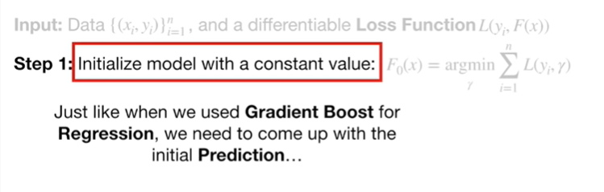

Just like when we used gradient boost for regression we need to come up with the initial prediction

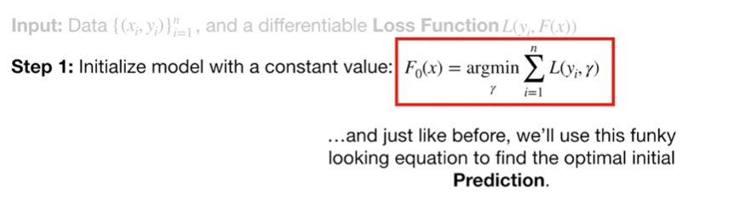

and just like before we'll use this funky-looking equation to find the optimal initial prediction.

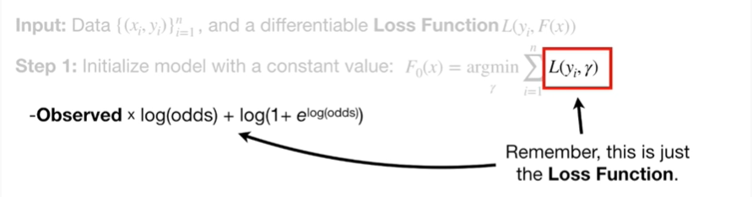

Remember, this is just the loss function.

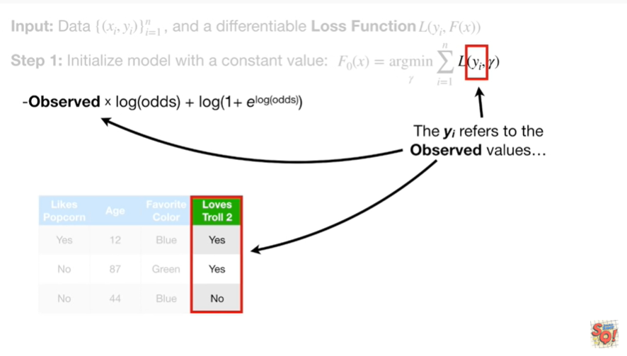

The y sub i refers to the observed values

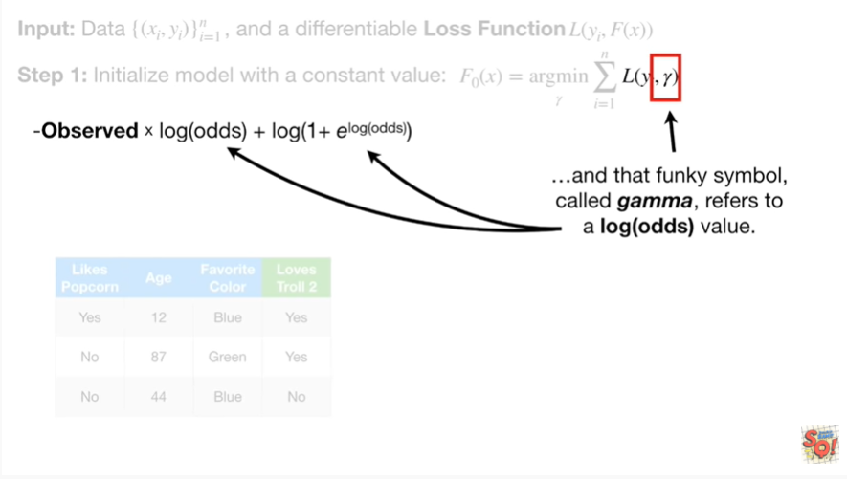

and that funky simple called gamma, refers to a log-odds value.

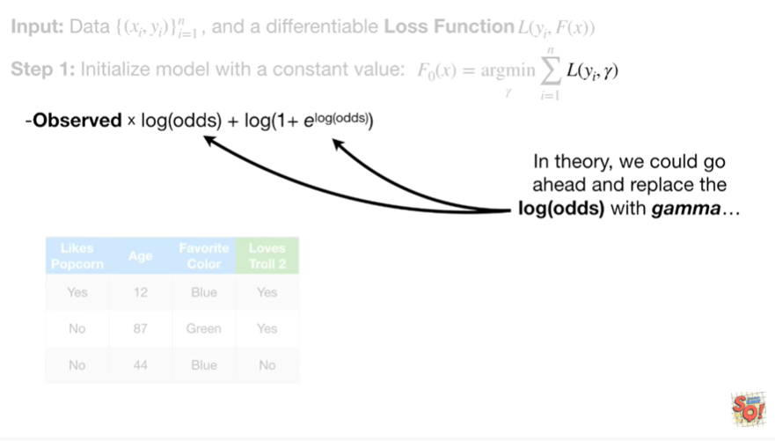

In theory, we could go ahead and replace the log odds with gamma

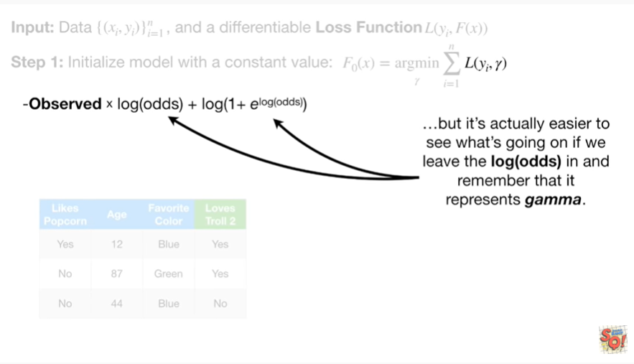

but it's actually easier to see what's going on if we leave the log odds in and remember that it represents gamma.

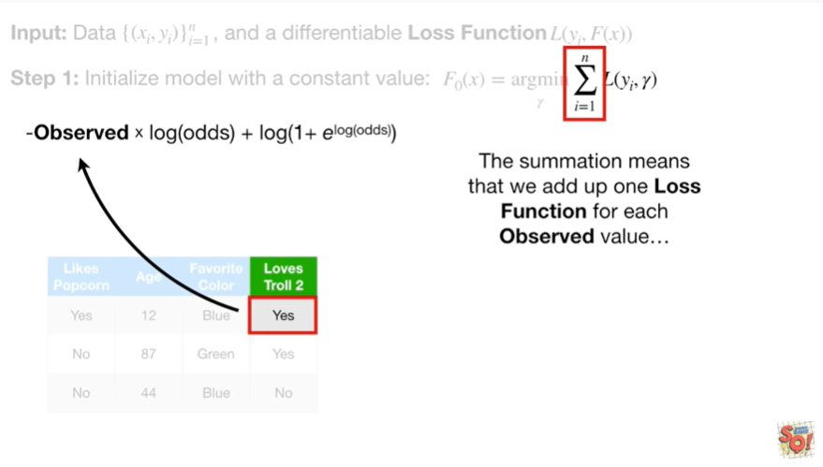

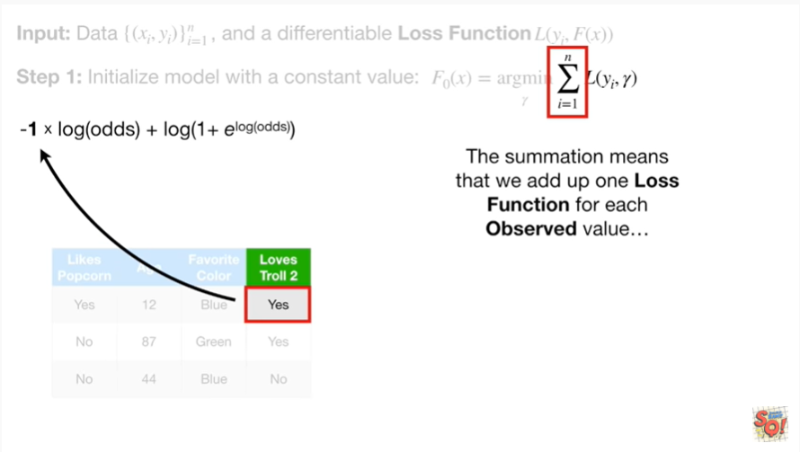

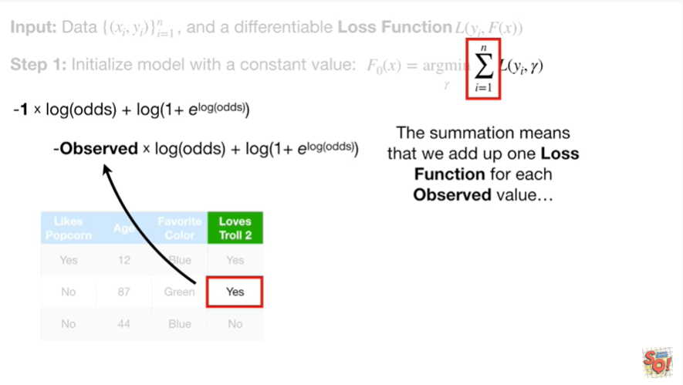

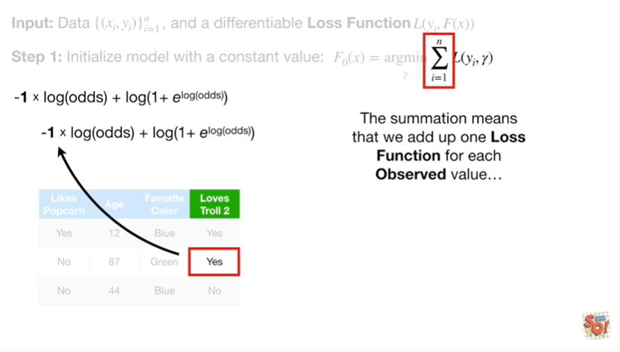

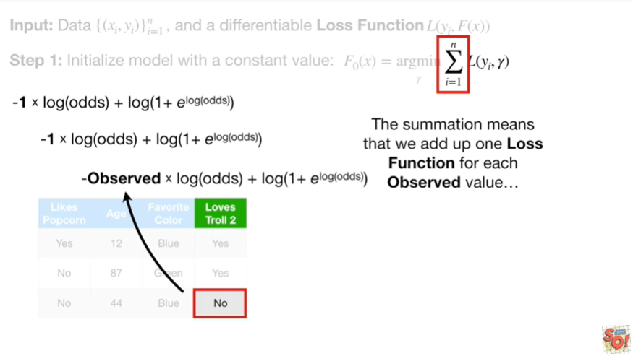

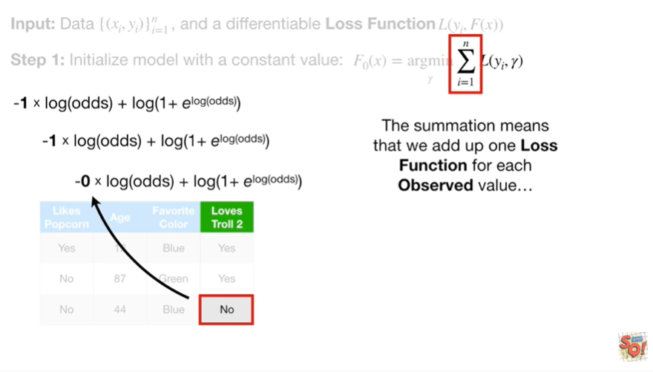

The summation means that we add up 1 loss function for each observed value

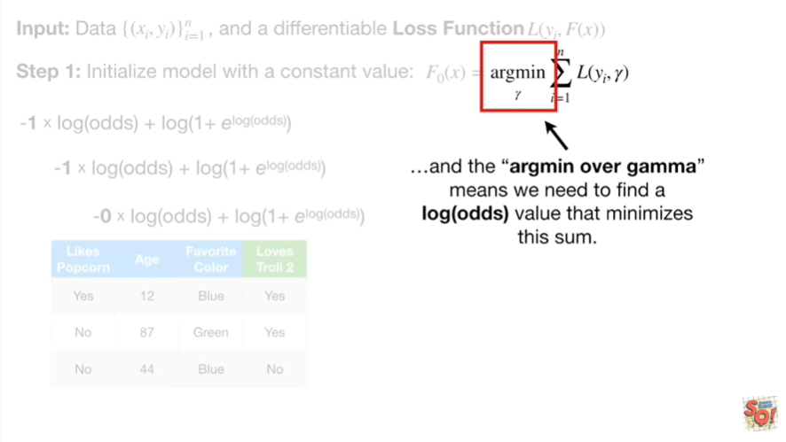

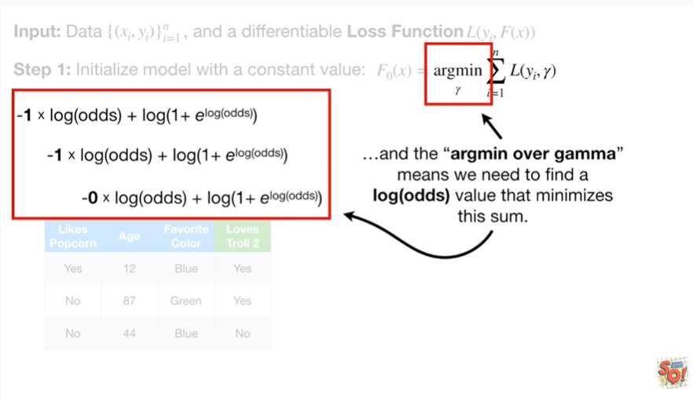

and the argmin over gamma means we need to find a log odds value that minimizes this sum.

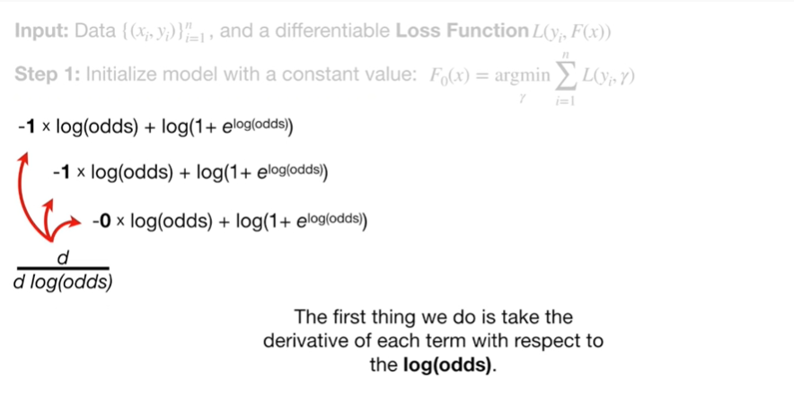

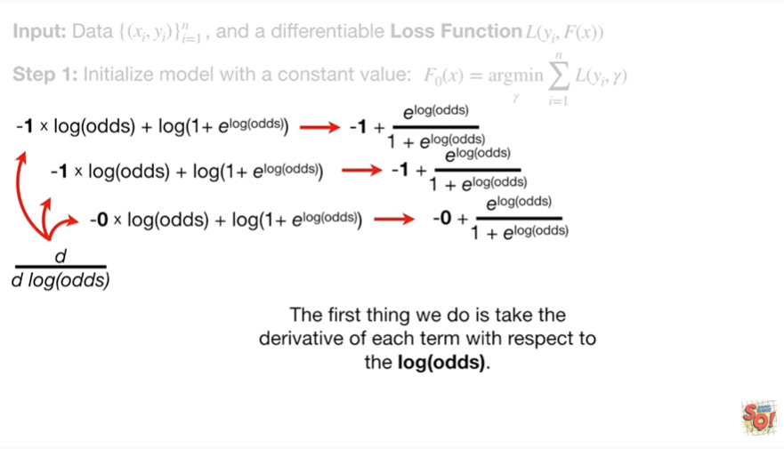

The first thing we do is take the derivative of each term with respect to the log odds.

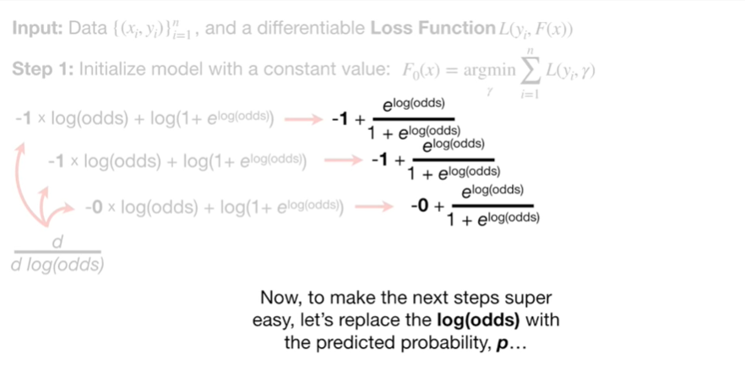

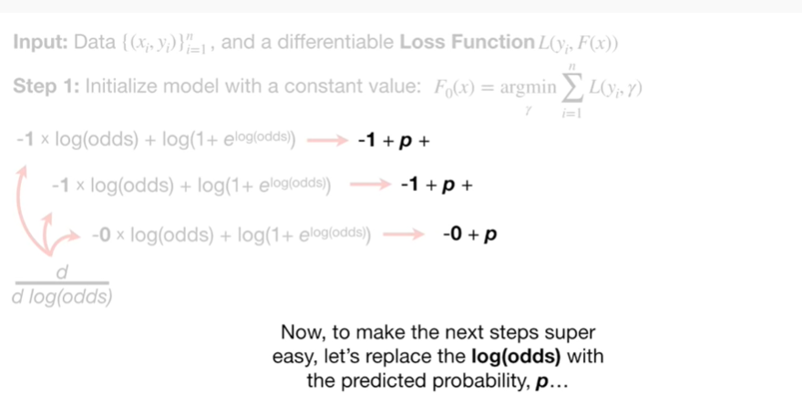

Now, to make the next step super-easy let's replace the log odds with the predicted probability, P

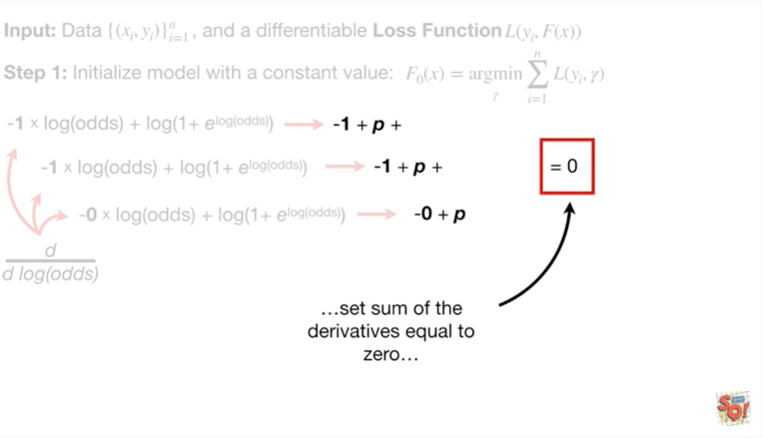

and set the sum of the derivatives equal to zero

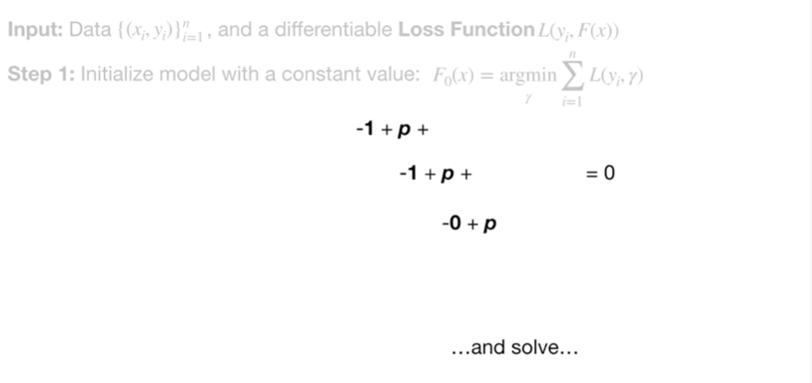

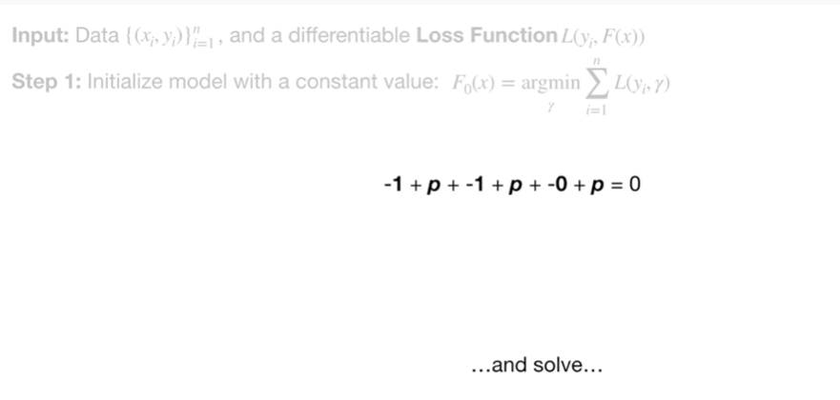

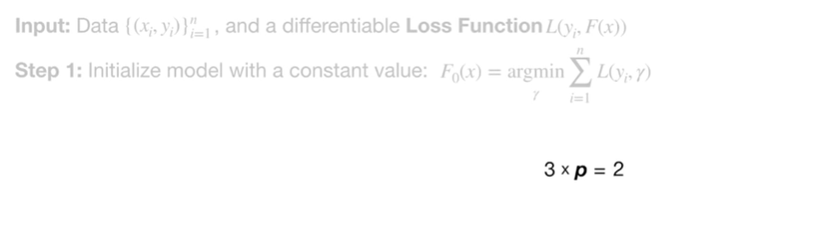

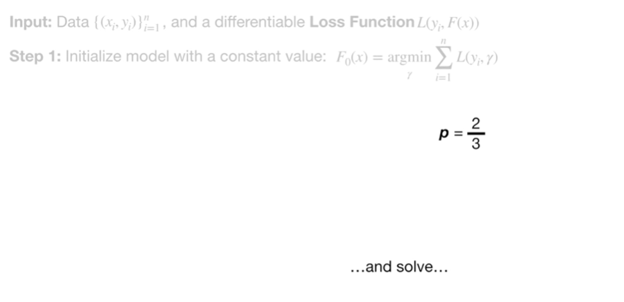

and solve

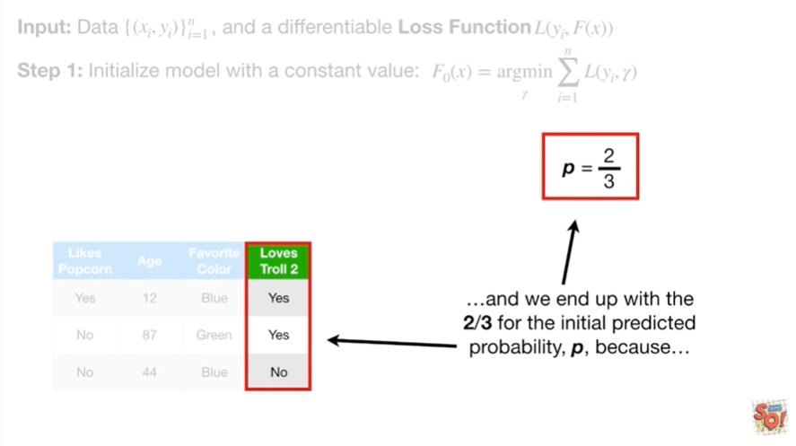

and we end up with 2/3 for the initial predicted probability, P, because

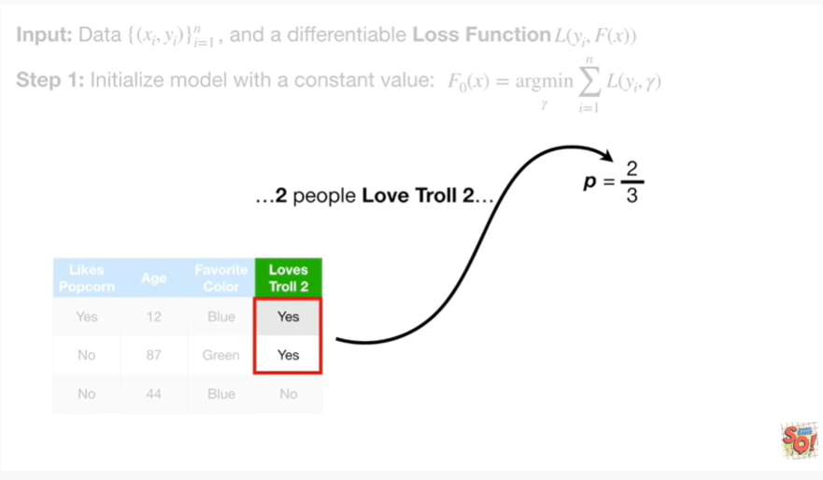

two people love troll 2

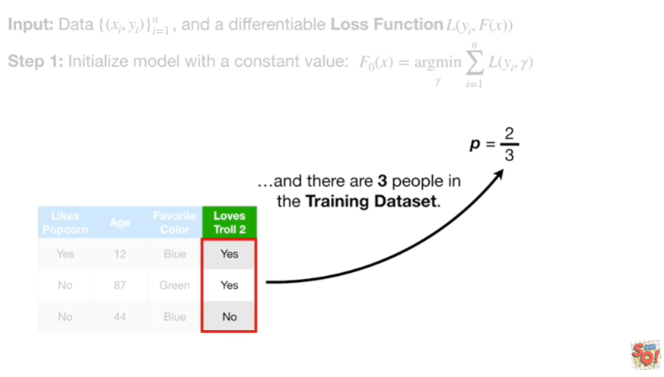

and there are three people in the training data set.

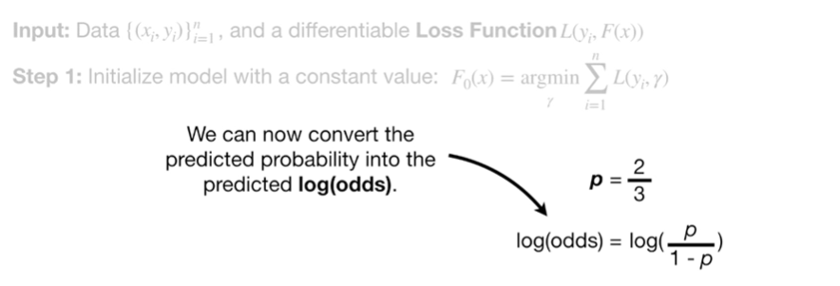

Now we can convert the predicted probability into the predicted log odds.

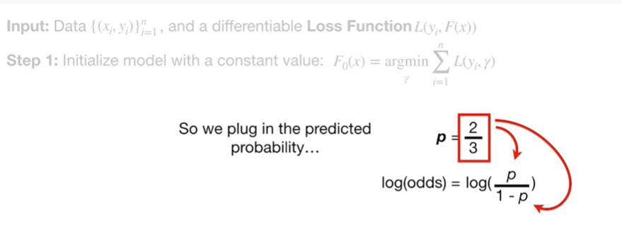

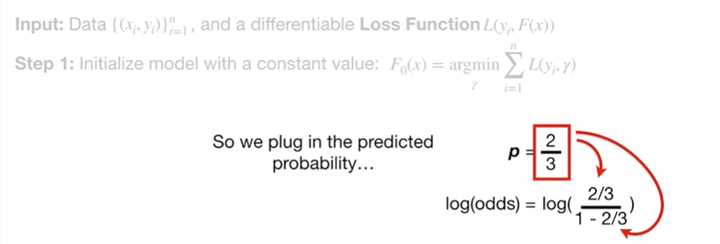

So we plug in the predicted probability

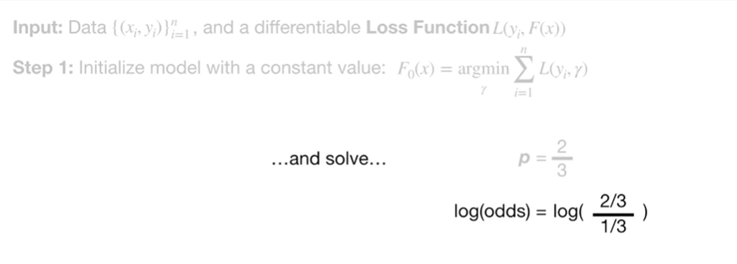

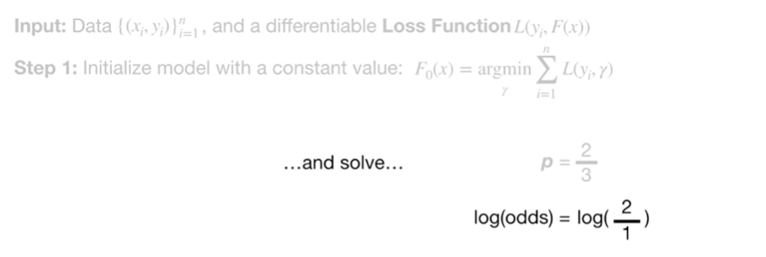

and solve

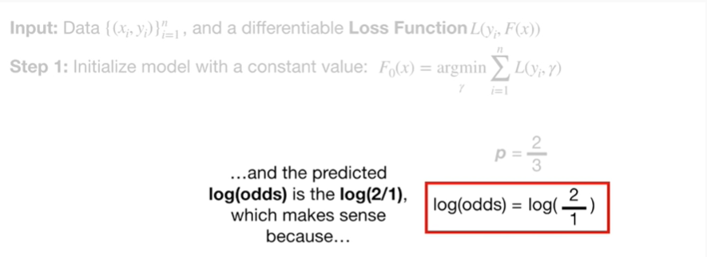

and the predicted log-odds is the log of 2/1, which makes sense because

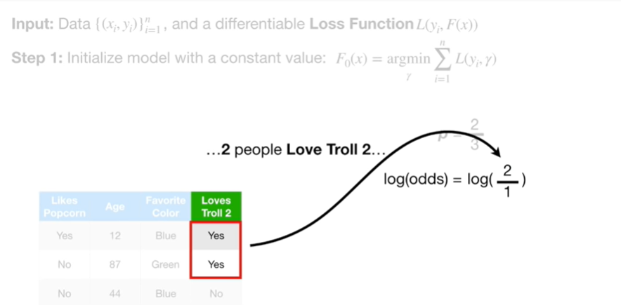

two people love troll two

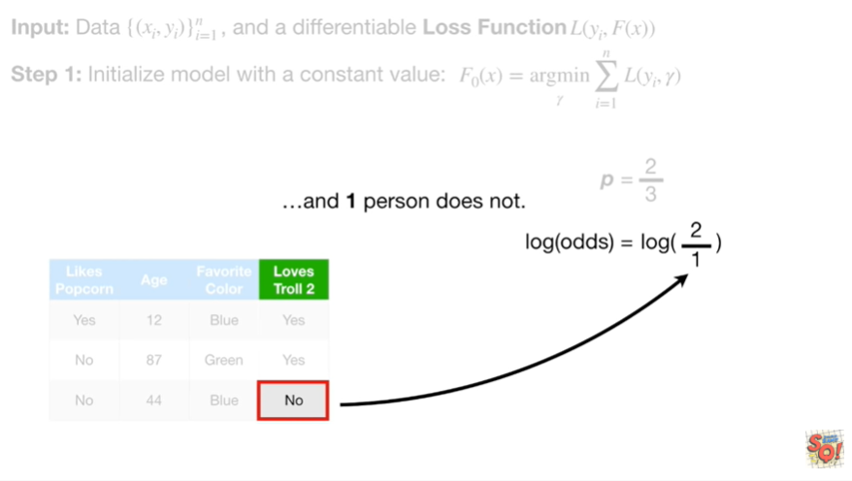

and one person does not.

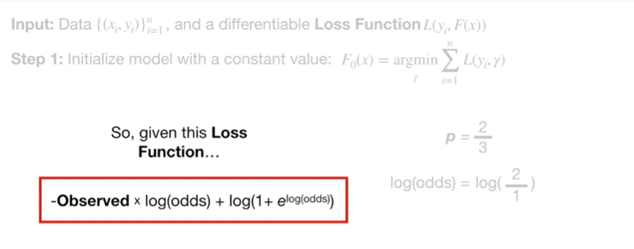

So given this loss function

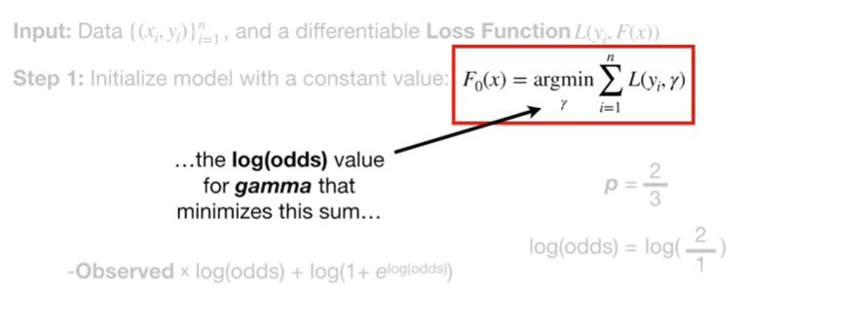

the log odds value for gamma that minimizes this sum

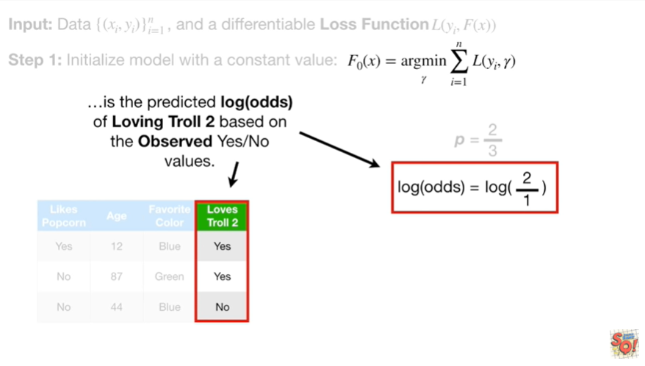

is the predicted log odds of loving troll two based on the observed yes/no values.

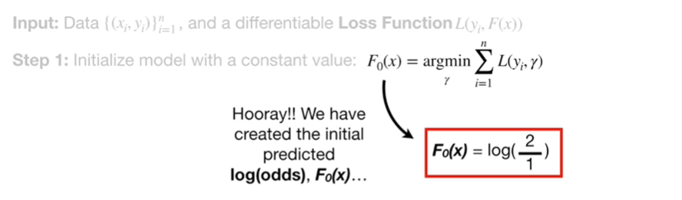

Hooray !

We've created the initial predicted log odds, F sub zero of x.

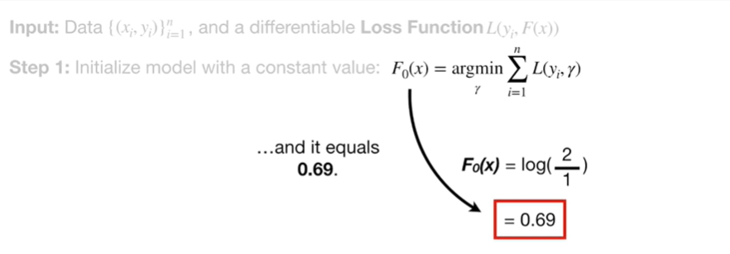

And it equals zero point six nine.

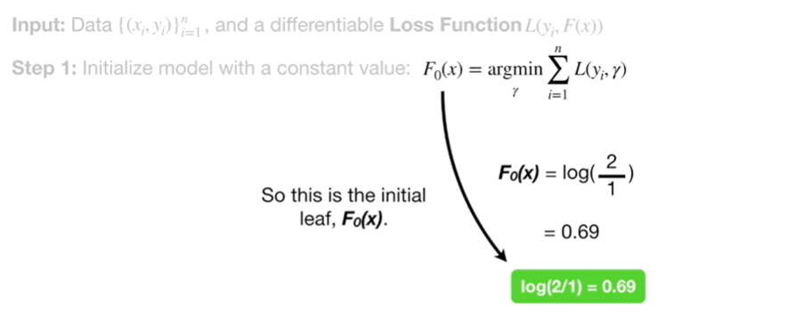

So this is the initial leaf F sub zero of x.

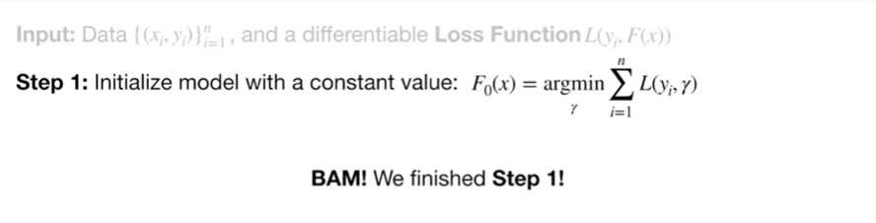

BAM !

We finish step 1.

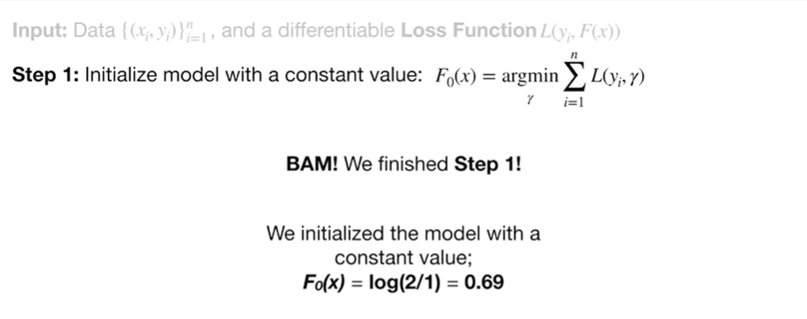

We initialize the model with a constant value, F sub zero of x equals the log of 2 divided by 1 which equals zero point six nine.

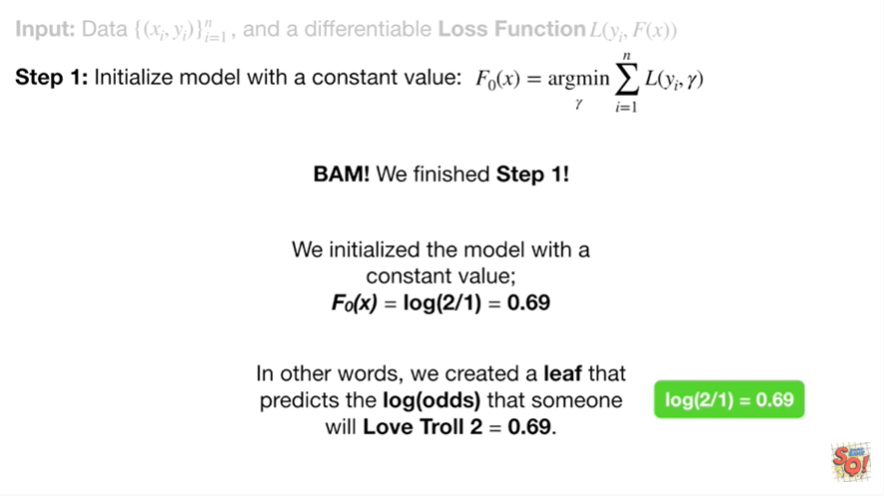

In other words we created a leaf that predicts the log odds that someone will love troll two and it equals zero point six nine.

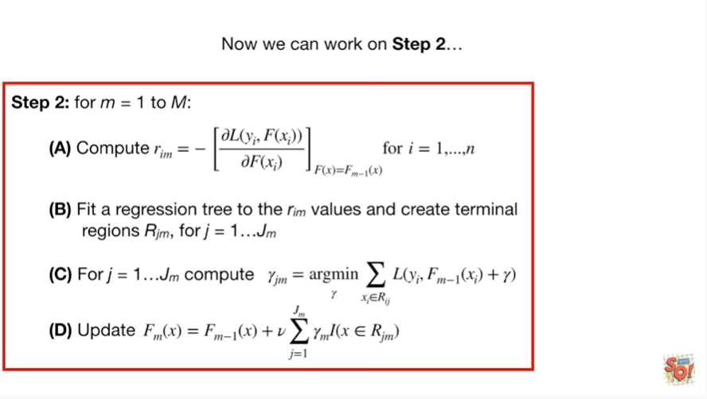

Now we can work on step 2.

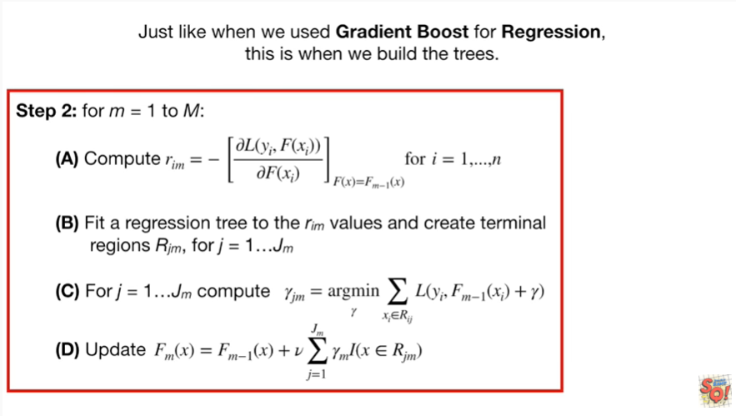

Just like when we used gradient boost for regression, this is when we'll build the trees.

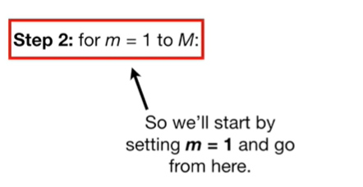

So we'll start by setting little m equal to one and go from here.

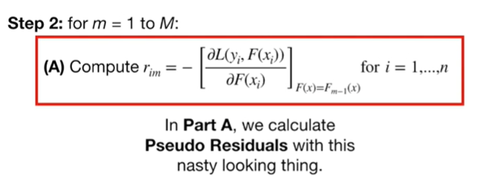

In Part A, we calculate pseudo residuals with this nasty looking thing.

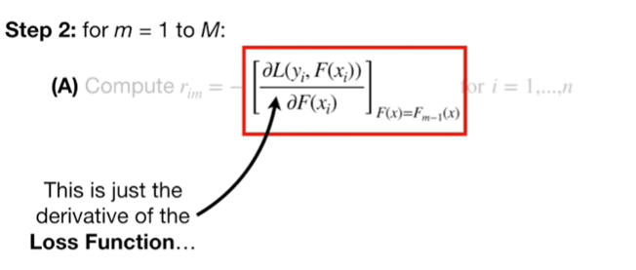

This is just the derivative of the loss function

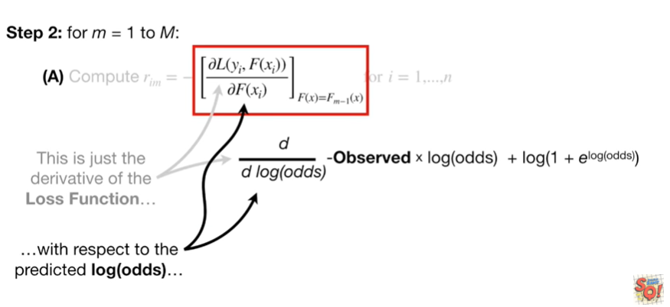

with respect to the predicted log odds

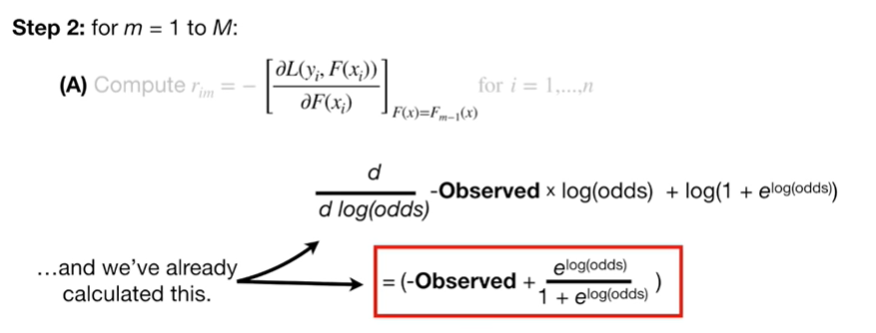

and we've already calculated this.

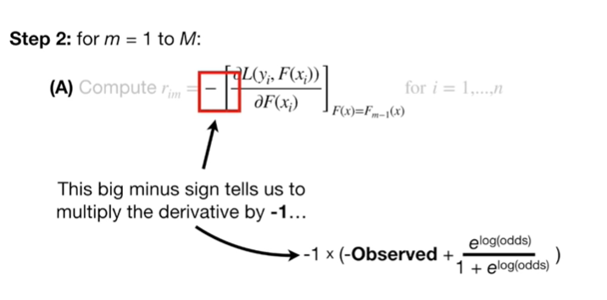

This big minus sign tells us to multiply the derivative by negative one

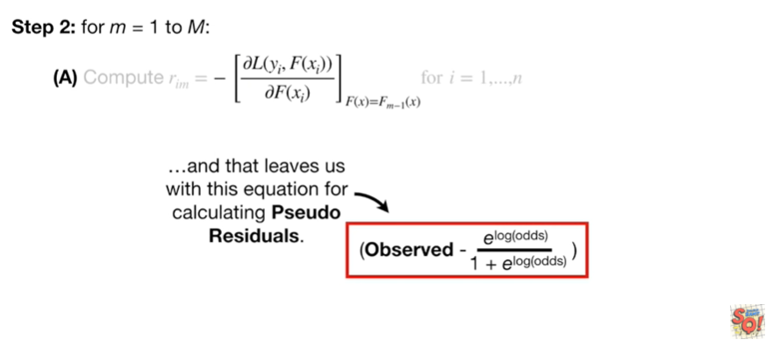

and that leaves us with this equation for calculating pseudo residuals.

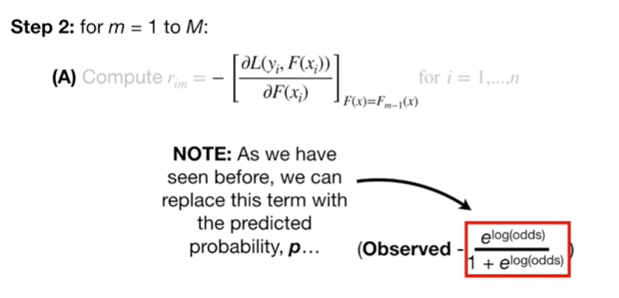

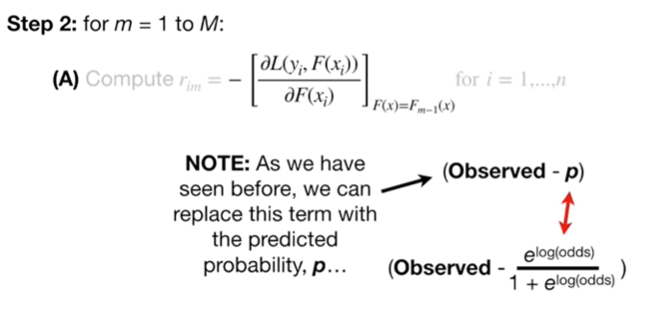

Note : as we have seen before we can replace this term with the predicted probability P

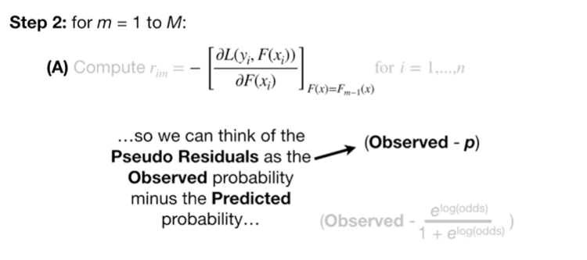

so we can think of the pseudo residuals as the observed probability minus the predicted probability

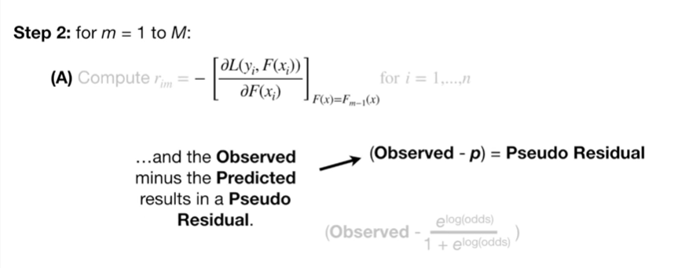

and the observed minus the predicted results in a pseudo residual.

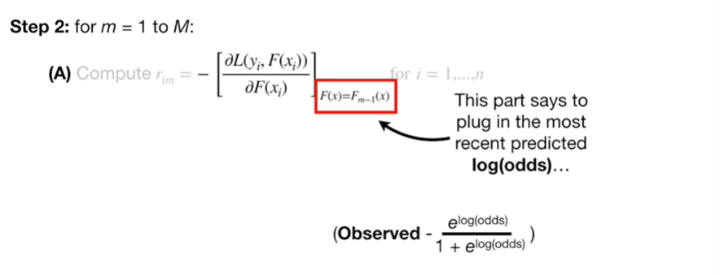

This part says to plug in the most recent predicted log odds

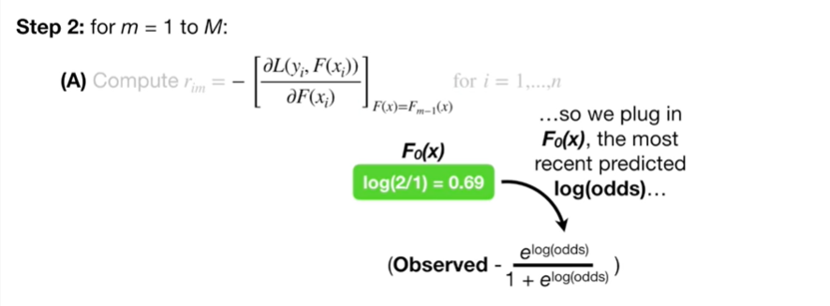

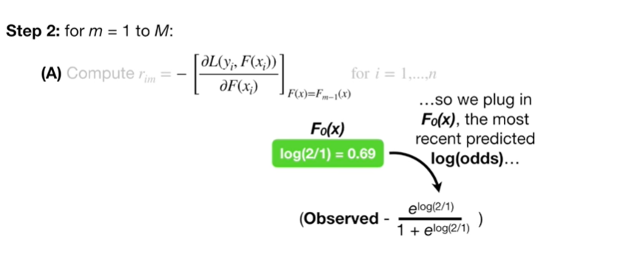

so we plug in F sub zero of X the most recent predicted log odds

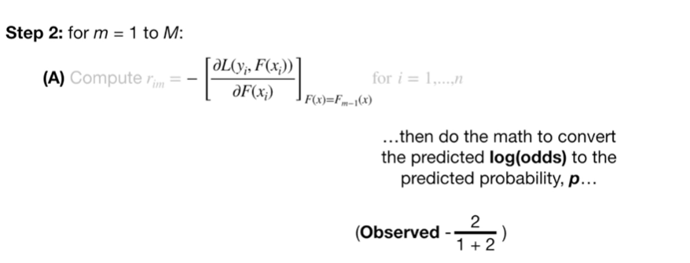

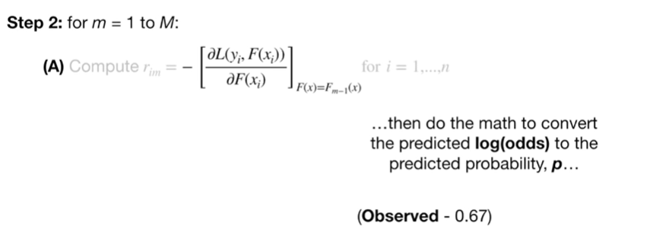

then do the math to convert the predicted log odds into the predicted probability P.

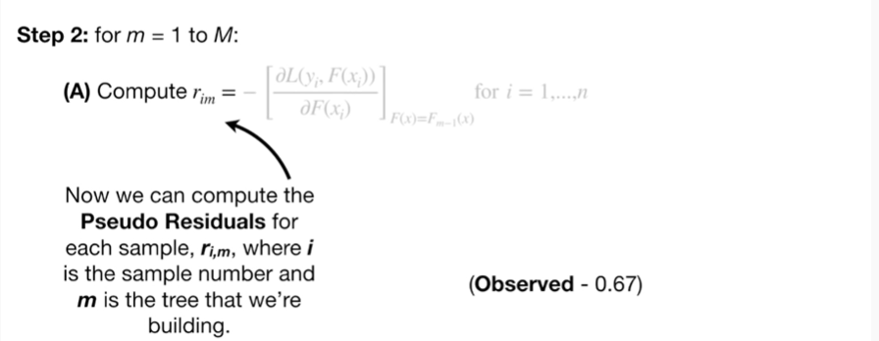

Now we can compute the pseudo residuals for each sample R sub I comma M where I is the sample number and M is the tree that we're building.

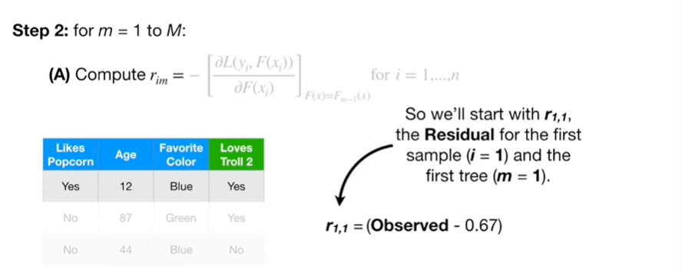

So we'll start with our sub 1 comma 1 the residual for the first sample and the first tree

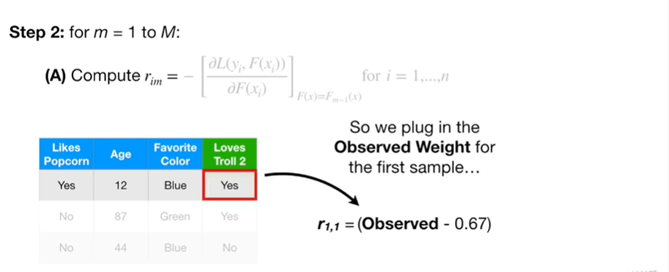

so we plug in the observed weight for the first sample

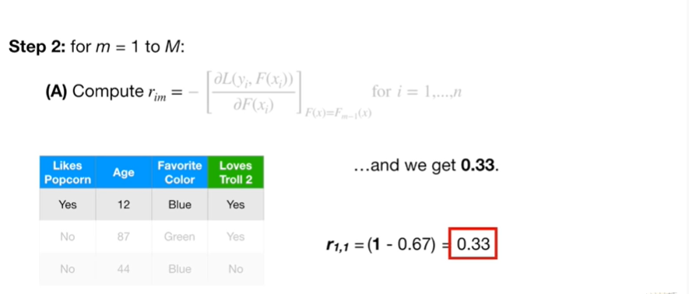

and we get 0.33.

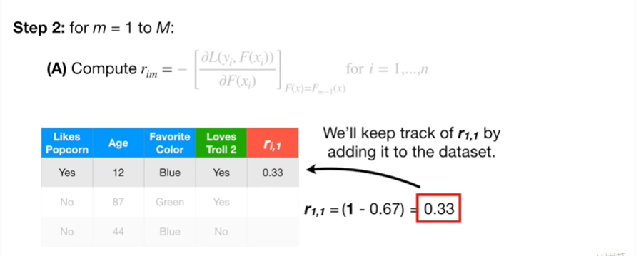

We'll keep track of our sub 1 comma 1 by adding it to the data set.

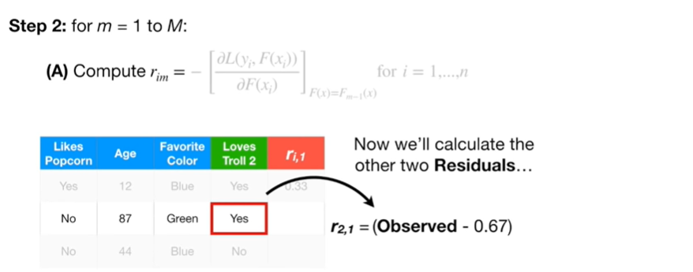

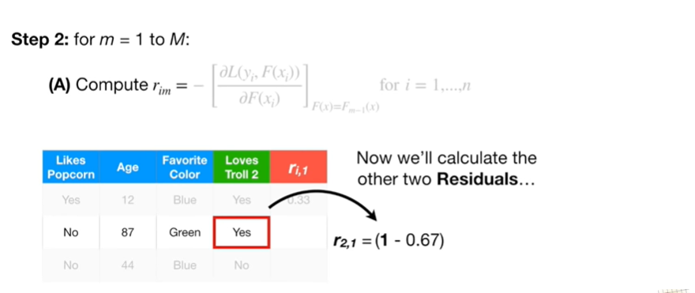

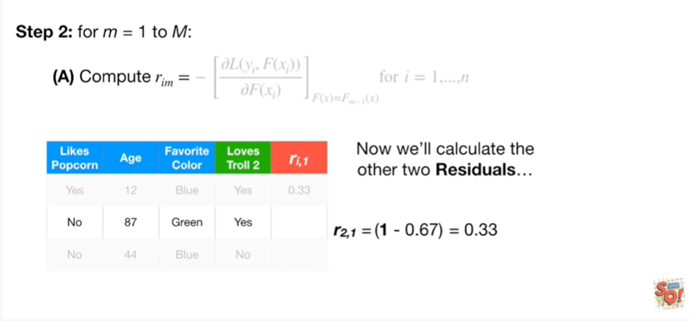

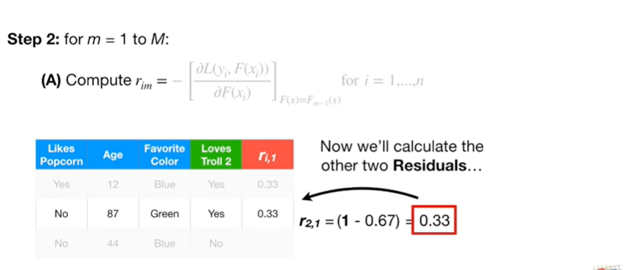

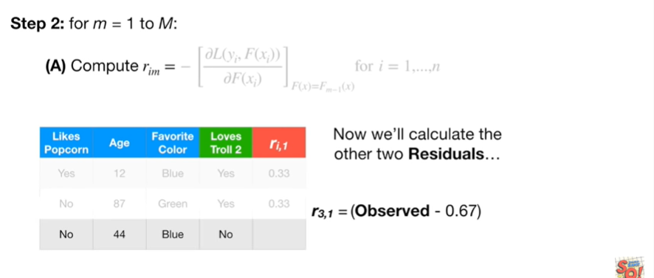

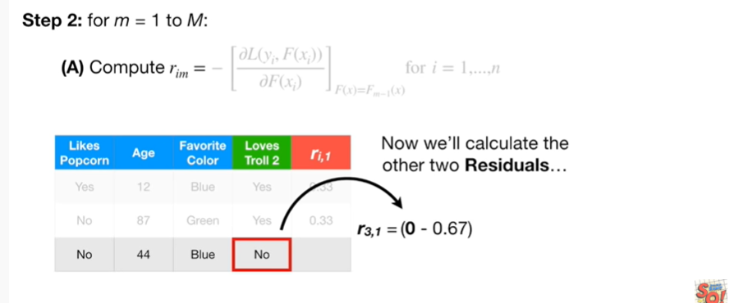

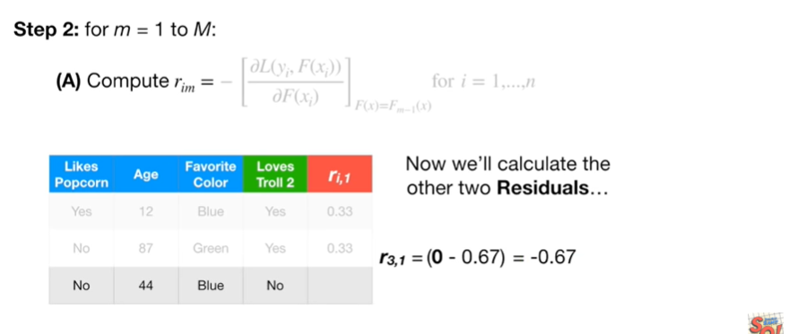

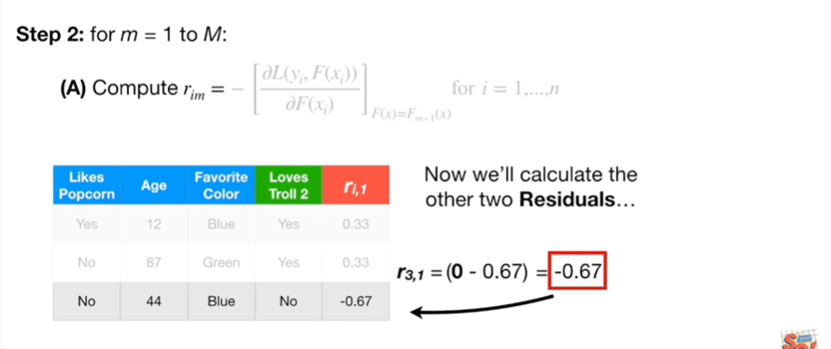

Now we'll calculate the other two residuals.

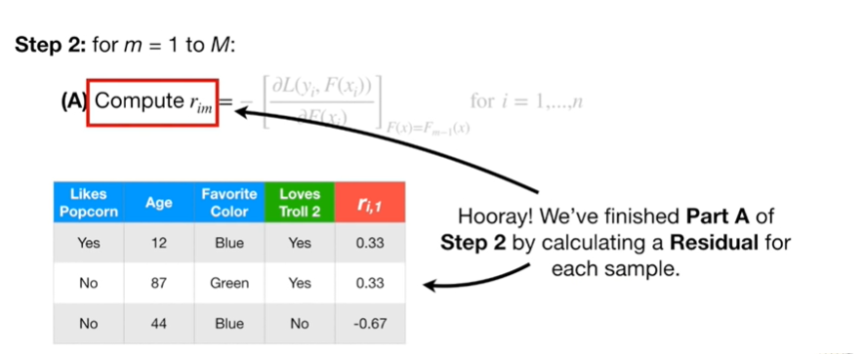

Hooray !

We finished Part A of step 2 by calculating a residual for each sample.

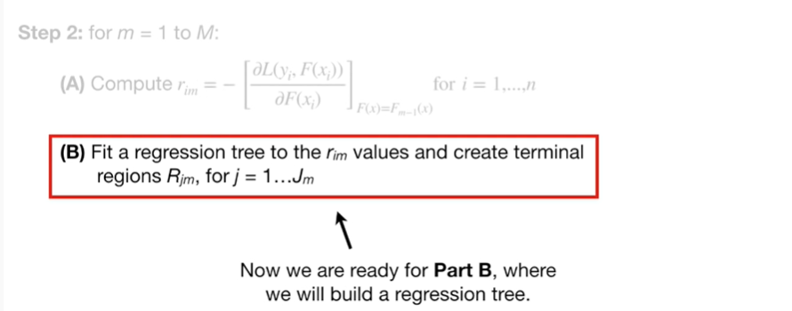

Now we're ready for Part B, where we will build a regression tree.

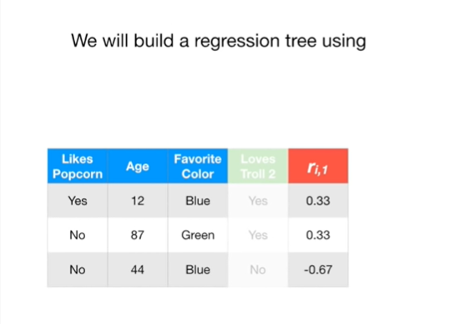

We will build a regression tree using

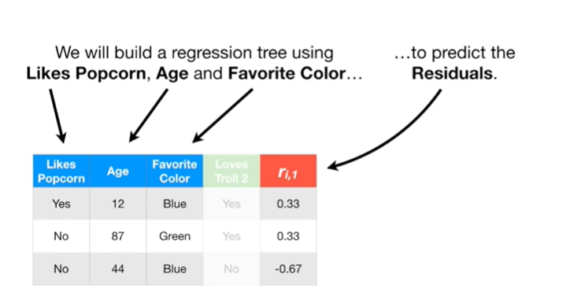

likes popcorn age and favorite color to predict the residuals.

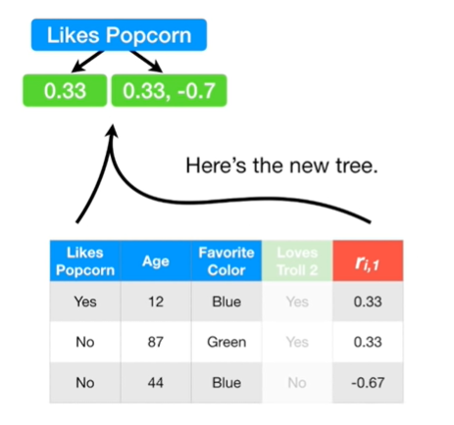

Here's the new tree.

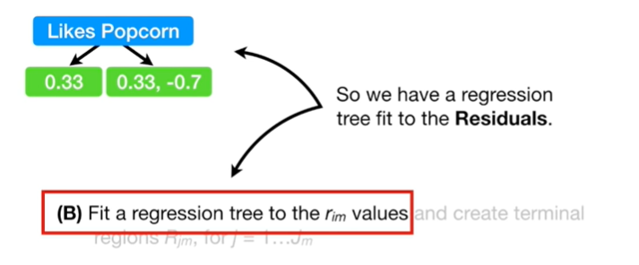

So we have a regression tree fit to the residual.

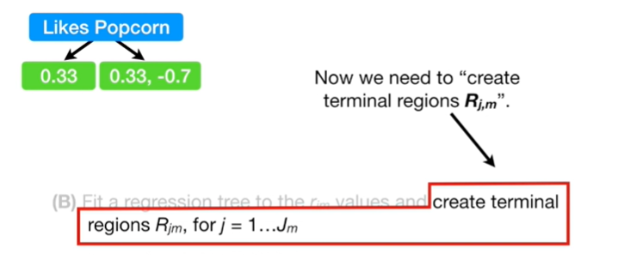

Now we need to create terminal regions R sub J comma M.

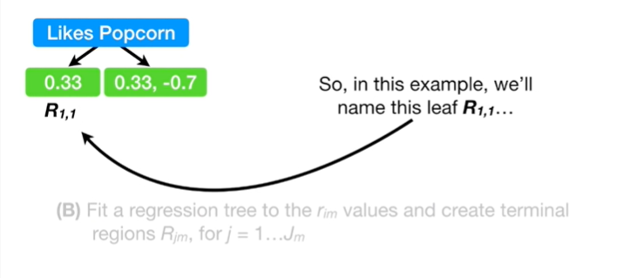

So, in this example, we'll name this leaf R sub 1 comma 1

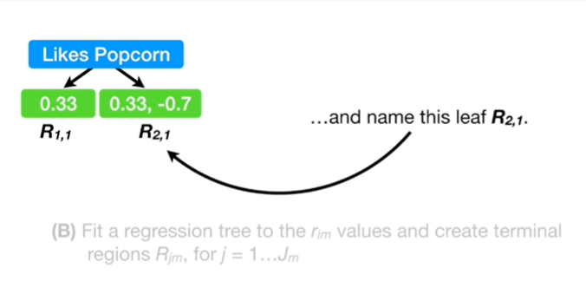

and name this leaf R sub 2 comma 1.

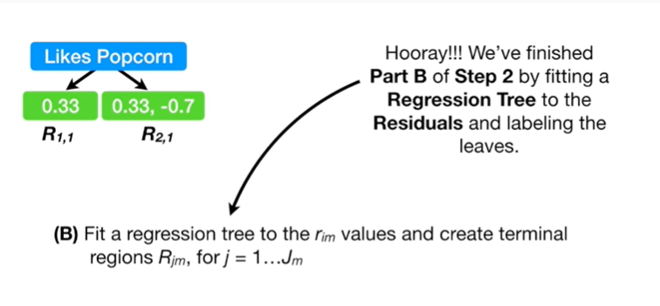

Hooray !

We finished part b of step 2 by fitting a regression tree to the residuals

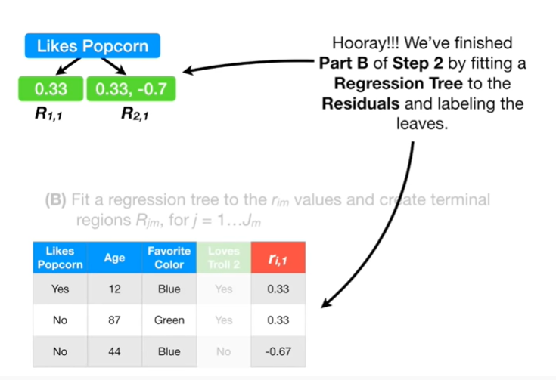

and labeling the leaves.

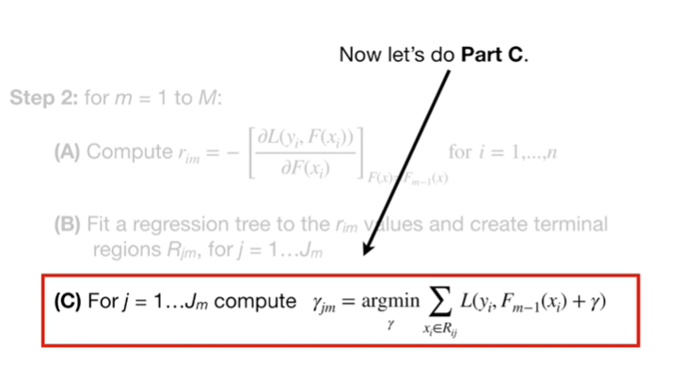

Now let's do Part C.

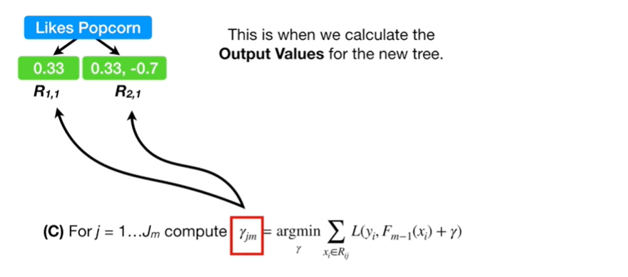

This is when we calculate the output values for the new tree.

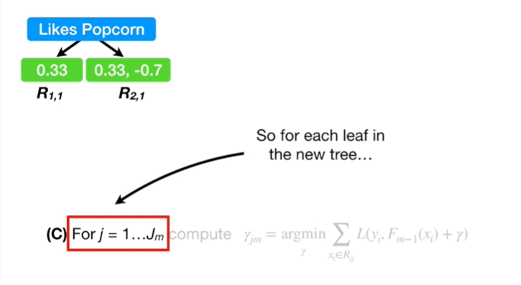

So for each leaf in the new tree

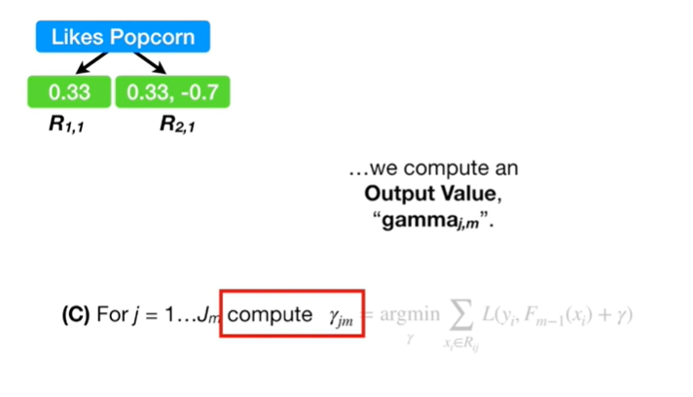

we compute an output value gamma sub J comma M.

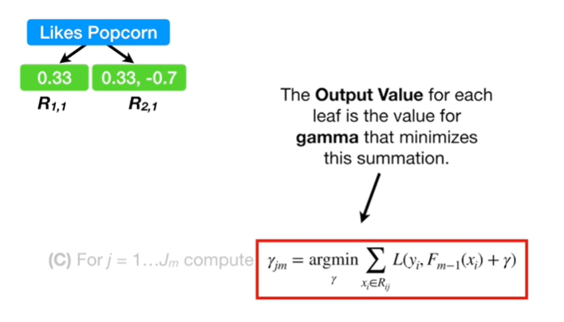

The output value for each leaf is the value for gamma that minimizes this summation.

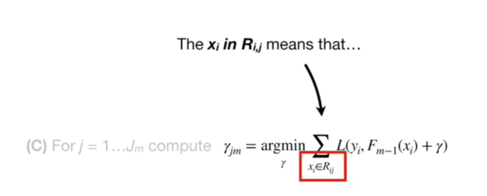

The X sub I and R sub I comma J means that

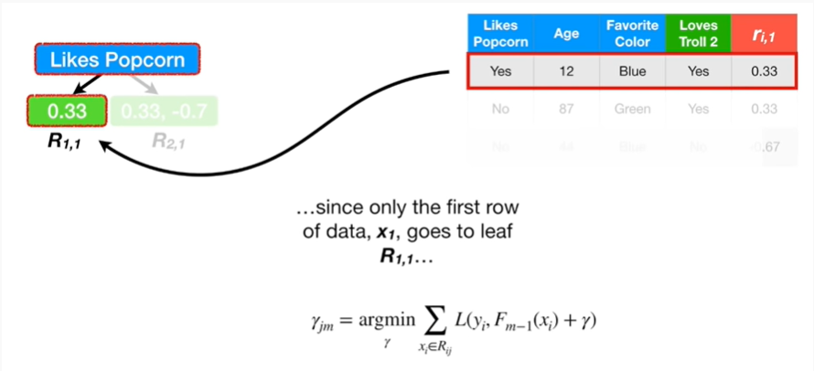

since only the first row of data X sub 1 goes to leaf R sub 1 comma 1

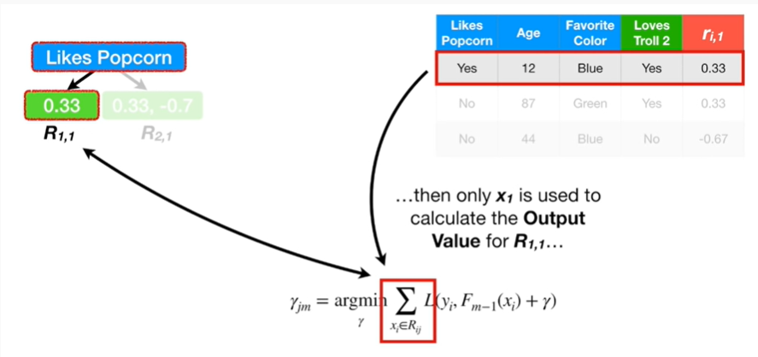

then only X sub 1 is used to calculate the output value for R sub 1 comma 1

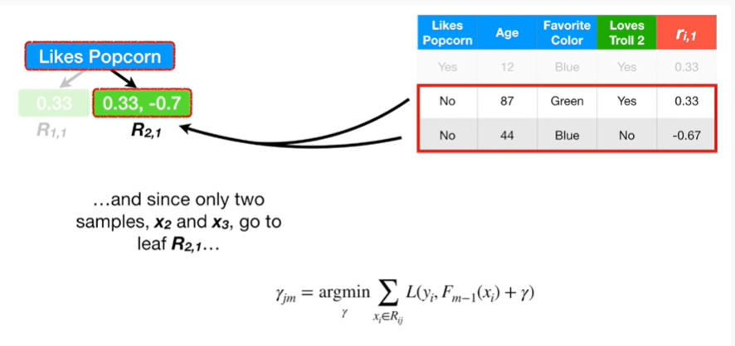

and since only two samples X sub 2 in X sub 3 go to leaf R sub 2 comma 1

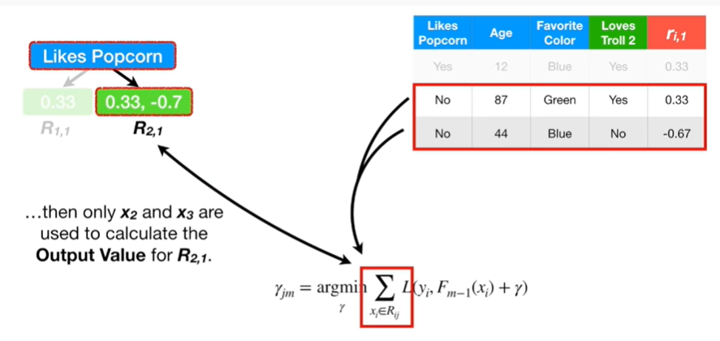

then only X sub 2 and X sub 3 are used to calculate the output value for R sub 2 comma 1.

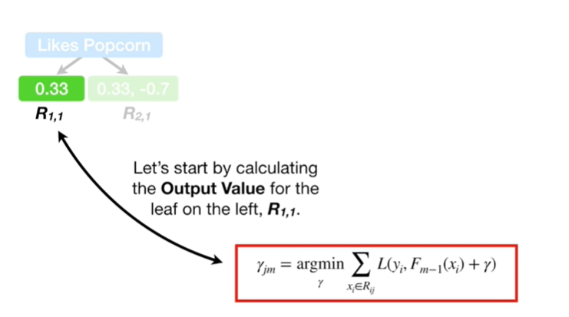

Let's start by calculating the output value for the leaf on the Left R sub 1 comma 1.

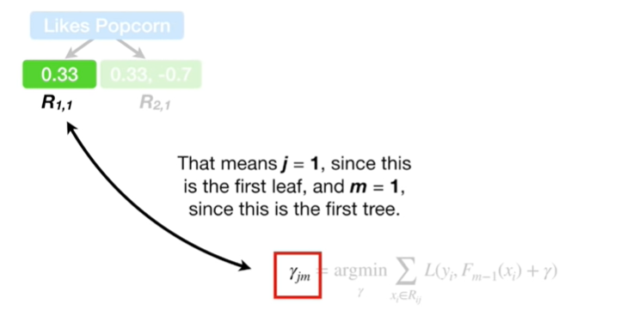

That means that J equals one since this is the first leaf and M equals one since this is the first tree.

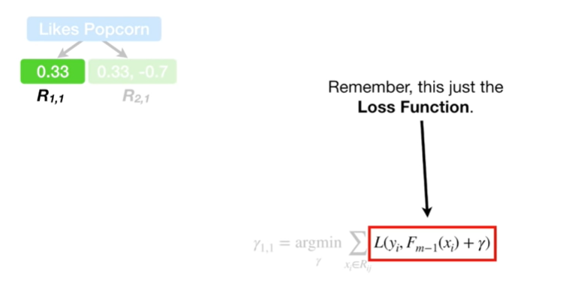

Remember, this is just the loss function

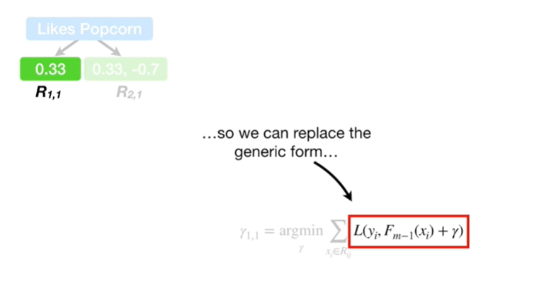

so we can replace the generic form

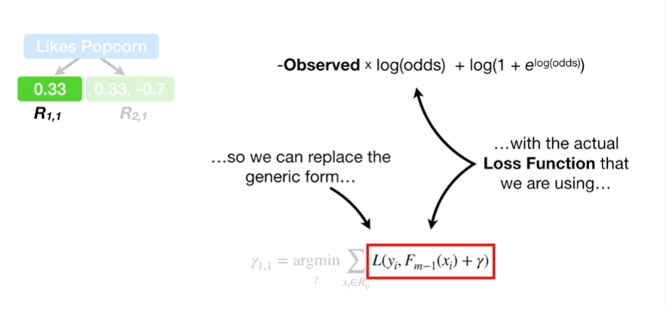

with the actual loss function that we are using.

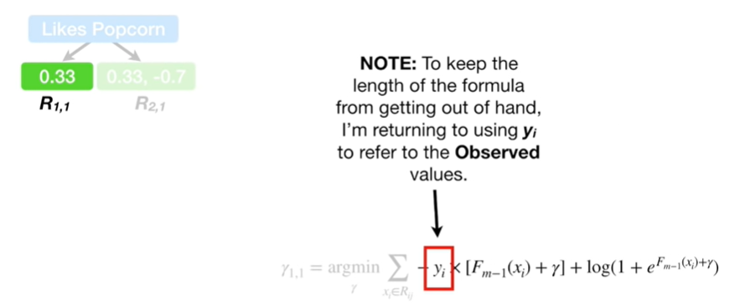

Note : to keep the length of the formula from getting out of hand I'm returning to using y sub I to refer to the observed values.

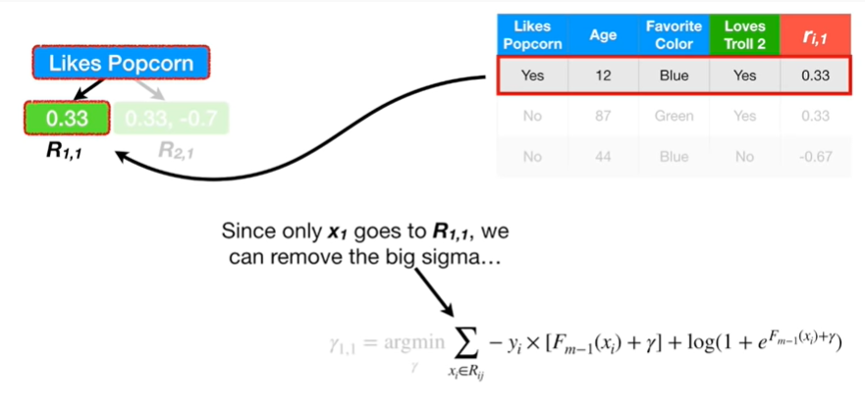

Since only X sub one goes to R sub 1 comma 1, we can remove the big Sigma

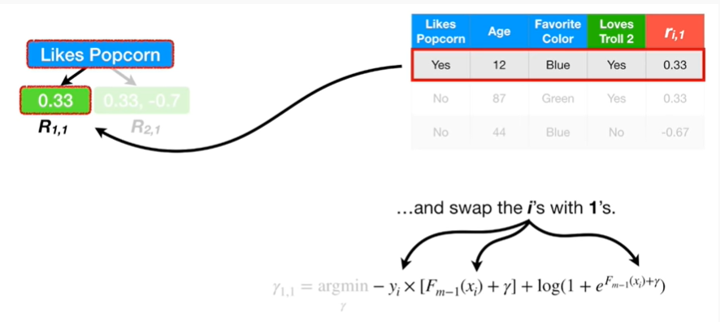

and swap the eyes with one’s.

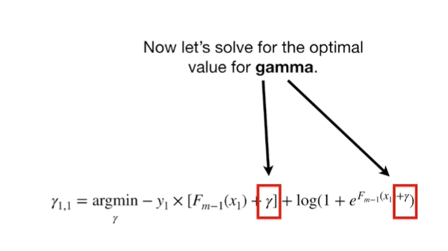

Now let's solve for the optimal value for gamma.

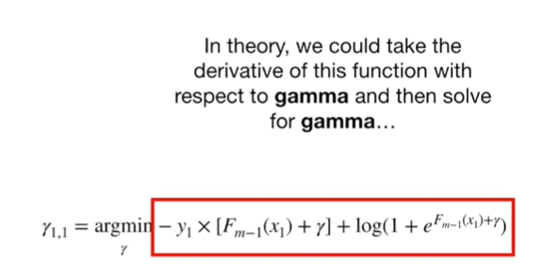

In theory we could take the derivative of this function with respect to gamma and then solve for gamma

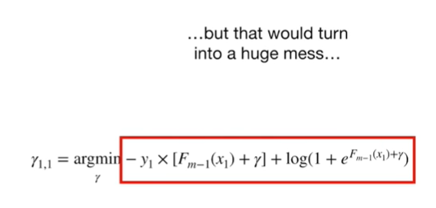

but that would turn into a huge mess

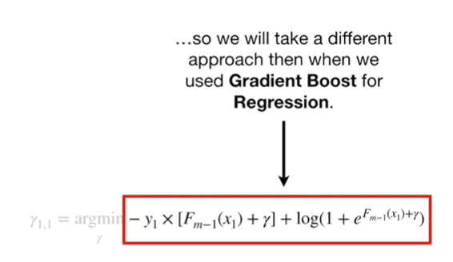

so we will take a different approach than when we used gradient boost for regression.

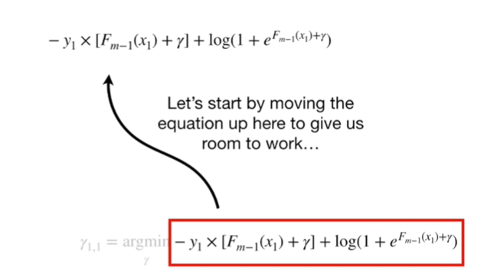

Let's start by moving the equation up here to give us room to work

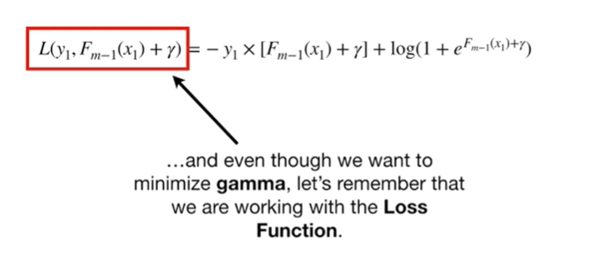

and even though we want to minimize gamma, let's remember that we are working with the loss function.

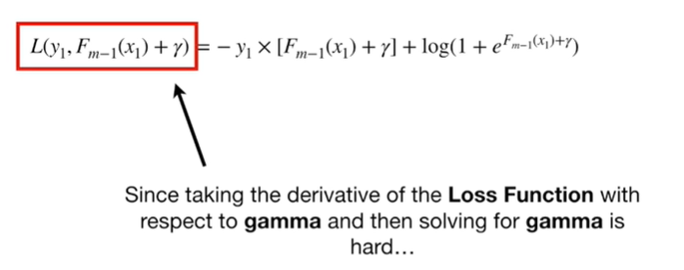

Since taking the derivative of the loss function with respect to gamma and then solving for gamma is hard

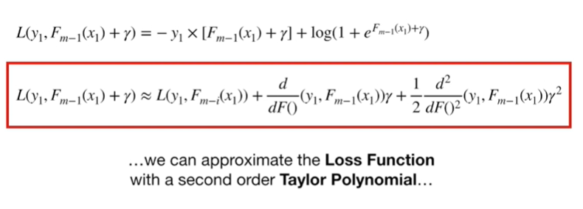

we can approximate the loss function with a second-order Taylor polynomial.

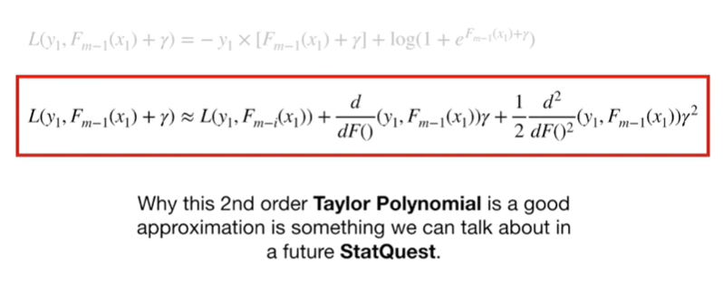

Why this second-order Taylor polynomial is a good approximation is something we can talk about in a future stat quest.